|  |
| --- |
| Texas Instruments |
| Keystone II Multicore Workshop |
| ARM-based Lab Manual |

March 2015

Contents

Prerequisites 1

Hardware 1

Software 1

Workshop Network 3

Setting up a Serial Terminal Session to the EVM via USB 4

Setting up a VNC View to the Ubuntu Server 4

Updating the U-BOOT 5

Update SPI NOR Flash with U-boot GPH image 5

Server Directory Structure 6

Lab 1: EVM Board Bring-up 7

Purpose 7

Load and Run standard “Hello World” application 7

Lab 2: Build a New ARM Program 12

Projects and Source Code 12

Purpose 12

Task 1: Modify the File System 12

Task 2: Retrieve Example Simple Code 13

Task 3: Build the Executable 14

Task 4: Unzip and Decompress the File System & Add New Executable 15

Task 5: Compress and Zip the New File System 16

Task 6: Reboot the EVM and Run the New Program 16

Lab 3: Boot Using NFS-mounted File System 19

Purpose 19

Task 1: Build a File System on a Linux Host, Use the NFS Server 19

Task 2: Configure U-BOOT to Mount the File Server and Boot 20

Task 3: Build a New C Program in the File System and Debug It 21

Lab 4: Boot Using USB Flash Drive 23

Purpose 23

Task 1: Preparing the USB 23

Task 2: Reboot the EVM 29

Lab 5: Build, Run and Optimize DSP Project Using CCS 31

Purpose 31

Project Files 31

Task 1: Build and Run the Project 31

Task 2: Define the Target 41

Task 3: Connect to the EVM 42

Task 4: Load and Run CASE 1 43

Task 5: Use Optimization and Disable Symbol Debug for the fir Filter Routine 44

Task 6: Optimize Software Pipeline 46

Task 7: Enable the Cache 48

Task 8: Running in Parallel on Multiple Cores 49

Lab 6: Load and Run DSP Code Using MPM Server 53

Purpose 53

Project Files 53

Task 1: Build and Run the Project 53

Task 2: Using MPM to Load, Run and Observe Results 56

Lab 7: ARM-DSP Communication Using MPM & Shared DDR 59

Purpose 59

Linux and DSP Simple Memory Management 59

Building the Project with the Default Platform 60

Task 1: Build and Run the Project 60

Task 2: Using MPM to Load, Run and Observe Results 66

Task 3: Modify the Platform and Run Again 68

Lab 8: ARM Optimization Using SMP Linux 70

Projects and Source Code 70

Purpose 70

Task 1: Copy the Source Files 70

Task 2: Compile, Build, & Run the Project on a Single Core 72

Task 3: Run the Code on Multiple Cores 75

Lab 9: Inter-Processor Communication (IPC) 77

Projects and Source Code 77

Purpose 77

Task 1: Run the Demo from a Web Server 77

Task 2: Run the Demo from the Terminal 82

Task 3: Rebuild the Executable 85

Task 4 (Optional): Modify Source Code & Rebuild Executable 92

# Prerequisites

The following hardware and software are needed to perform the labs in this manual.

## Hardware

1. Update BMC and UCD on EVMK2H (optional):
   1. The wiki page <http://processors.wiki.ti.com/index.php/EVMK2H_Hardware_Setup> gives instructions on how to detect if the board needs BMC (Baseboard Management Controller) update. It also instructs how to do the update the BCM using CCS.  
      NOTE: A PDF version of the wiki page (KeyStone2_EVM_hardwareSetUp.pdf) is also available. Ask your instructor.
   2. The user must also check the UCD Power Management version (see EVMK2H Hardware Setup at link above) and update if necessary.  
      NOTE: Instructions and scripts that show how to update the UCD are provided in the zip file XTCIEVMK2X-UCD-Update.zip (ask your instructor).
2. TI training EVMs are already updated. The above update may be required on a customer’s personal EVM.

## Software

The following software packages must be pre-installed on the student laptop before the workshop starts. NOTE: During the workshop, the laptop is attached to local network and has limited access to internet.

1. Download the MCSDK and CCS:
   1. For details regarding the instructions in this section, refer to the [MCSDK User Guide for KeyStone II](http://processors.wiki.ti.com/index.php/MCSDK_User_Guide_for_KeyStone_II).
   2. The latest release of MCSDK is found here:  
      <http://software-dl.ti.com/sdoemb/sdoemb_public_sw/mcsdk/latest/index_FDS.html>
      1. For this lab you can use the Windows or the Linux version, depends on your laptop. Linux MCSDK was pre-installed on an Ubuntu server that will be used in some of the labs.
   3. From the same download page as the MCSDK, locate and download the latest CCS version and the emupack version that goes with the CCS. Follow the instructions on the page. Note, installing CCS requires licensing from TI.
2. Installing VNC Viewer:

VNC server that supports graphic interface was installed on the Ubuntu server. Each laptop must have a VNC viewer. Texas Instruments and many other corporations purchased global licenses for Real VNC enterprise users and it can be downloaded from internal software download site (EDS). Limited functionality Real VNC viewer is available as freeware from multiple sites.

1. FTP Client

FTP server is installed on the Ubuntu server. Moving files between the student Laptop and the Ubuntu server can be done with the enterprise version of Real VNC or (if the student uses a freeware real VNC) by using ftp client on the laptop. The student must confirm that ftp client is installed on the laptop.

1. For communication between the student PC and the EVM, the FTDI driver is required. As needed, download the 32-bit driver here: <http://www.ftdichip.com/Drivers/D2XX.htm>
2. Terminal emulator such as Tera Term or Putty (or other). Tera Term is installed on TI’s laptops.
3. It is assumed that the user knows how to use the tools, VNC, terminal emulator, and FTP client.

### 

### Workshop Network



The diagram above shows the workshop network environment:

* There are up to 10 lab stations. EVMs at each station are numbered from 1 to 10. Each station has the following:
  + One EVMK2H
  + One laptop that is connected to the EVM via JTAG cable.
  + One optional laptop that is not connected to the EVM, called the second laptop in the station.
* All EVMs and students laptops are connected to the local network 192.168.0.XX via a wired connection to a switch or a router.
* The Ubuntu server is connected as well. The Ubuntu server has access to an external network with a global IP that have access to the Web.
* The IP addresses of the local network (192.168.0.XX) is provided by the Ubuntu server DHCP.

### Setting up a Serial Terminal Session to the EVM via USB

The EVM has two (mini) USB ports.

* + One of the ports accesses the JTAG connection and can be used to connect CCS to the board. This USB connector is part of the emulator daughter (mezzanine) card.
  + The second USB port is part of the mother board and can be used to connect two serial terminals into the EVM. We will refer to these serial terminals as Tera Term (to distinguish from the window viewer terminal to the Ubuntu machine). The tera-terminals are connected using a single USB cable but can be opened as two tera-terminals.
    - The first serial terminal (ARM Tera Term) is connected to the ARM terminal (e.g., the lower COM port)
    - The second serial terminal (BMC Tera Term) is connected to the FPGA/BMC on the board.
    - The user must open the two Tera Term connections and set the serial rate to 115200 Baud.

### Setting up a VNC View to the Ubuntu Server

Launch the VNC Viewer application from the desktop of your laptop/PC. The server IP will be given by the instructor. For static configuration, when DHCP is not available, the server IP is 192.168.0.100.

* + The login instance for student N is :N. For example, student 3 will VNC to address 192.168.0.100:3, while student number 7 will use 192.168.0.100:7.
  + The VNC password for all studentN is “studentN” where N is the student number in hexadecimal notation, that is, student10 password is studenta, and student11 password is studentb and so on.

## Updating the U-BOOT

The U-BOOT that is programmed into flash on the EVM must be updated when moving ti a new version of the MCSDK. The following process will be done at the beginning of every training session

### Update SPI NOR Flash with U-boot GPH image

The following process is used to update the U-BOOT image in SPI Flash. It must be done every time a new release of MCSDK is used.

1. Power cycle the EVM and stop the autoboot by pressing any key.
2. The image sub-directory of the MCSDK release (for MCSDK release 3.1.1.4 the image directory path is /tiTools/MCSDK_3_1_4\mcsdk_linux_3_X_Y_Z\images) has a gph file - **u-boot-spi-k2hk-evm.gph.** This file was copied to the TFTP root directory (see the table below for the path to the TFTP root directory)
3. Make sure the tftp server is running. Then issue the following commands to U-Boot console:

**setenv serverip 192.168.0.100**

**dhcp 0xc300000 u-boot-spi-k2hk-evm.gph**

**sf probe**

**sf erase 0 < the size of u-boot-spi-k2hk-evm.gph in hex up rounded to sector boundary of 0x10000>**

**sf write 0xc300000 0 <size of u-boot-spi-k2hk-evm.gph image in hex>**

NOTE: The size of the image will be displayed as part of the DHCP command.

# Server Directory Structure

The following directories and sub-directories were added to facilitate the workshop. The directory name includes the absolute path of any directory.

|  |  |  |
| --- | --- | --- |
| Directory | Purpose | Comments |
| /tiTools | Contains TI tools that are to be used by all students: Linaro cross compiler tool chain, CCS, and MCSDK | Sub-directories are MCSDK, CCS and Linaro tools chain (cross compiler) |
| /tiTools/CCS | CCS installation location |  |
| /tiTools/MCSDK_X_Y_Z | MCSDK installation directory, version number is X_Y_Z |  |
| /tiTools/gcc | Linaro tools chain – cross compiler |  |
| /tftpboot | Root directory for the TFTP server. | Each student has a sub-directory |
| / tftpboot /studentN | TFTP directory for student N, where N is 1 .., 10 | Student has to copy images from the MCSDK to this directory for ramfs boot |
| /opt/filesys | Root directory for the NFS server that enables mounting of the server file system into the EVM | Each student has a sub-directory |
| / opt/filesys /studentN | NFS directory for student N, where N is 1..,10 | Each student should build private file system into this directory |
| /global/scripts | This directory has scripts that initialize environment variables. studentStartInsideTI.sh is used when the server is inside TI network, and studentStartOutsideTI.sh is used when the server is outside the firewall. Other scripts may be developed for other locations | The student must run the script for every terminal by doing  Source /global/scripts/scriptXXX.sh |
| /global/projects | Contains the source code for projects that are used during the Lab. | It has two sub-directories, DSP and ARM. Students will copy the source code files from this directory to their private directories |
| /global/projects /ARM | Source code for ARM projects |  |
| /global/projects /DSP | Source code for DSP projects |  |
| /home/studentN | Home private directory of student N N=1 ..,10 | All changes to files are done in the student private directory |
| /global/git | All sources for TI Arago distribution |  |

# Lab 1: EVM Board Bring-up

## Purpose

The purpose of this lab is to boot the EVM from TFTP server. In addition to the kernel, device tree and the monitor, the file system is loaded from the TFTP server.

### Load and Run standard “Hello World” application

1. In order for the U-BOOT to get files from a sub-directory, the tftp download path for u-boot command needs to be specified via the **tftp_root** value. In our server, the root address of TFTP is /tftpboot. Each student has a private sub-directory /tftpboot/studentN where N is the student number.
2. Make a subdirectory **/tftpboot/studentN** if it does not exist already and copy the MCSDK release binary images into this directory. The binary images are located in the /tiTools/MCSDK_X_Y_Z/mcsdk_linux_X_Y_Z/images directory on the Ubuntu server, where X,Y and Z are the release number.

**cd /tftpboot/studentN**

Where N is the student number you have been assigned for this lab.

**cp /tiTools/MCSDK_3_X_Y_Z/mcsdk_linux_X_Y_Z/images/*.* .**

1. U-BOOT loading and running Linux Kernel using TFTP with ramfs file system
   1. First verify that the DIP switch (sw1) are in ARM SPI boot mode:  
      1 OFF 2 OFF 3 ON 4 OFF
   2. Power up EVM, look at the ARM tera-terminal window

* 1. After power cycle, press the return key to stop autoboot in the ARM tera-terminal
  2. Enter the following command to reset the current environment variables.

**env default -f –a**

* 1. MCSDK release has multiple file systems. The stripped-down file system name is **arago-console-image-k2hk-evm.cpio.gz**. This file system is small and does not have most of the applications. Two other file systems, tisdk-rootfs and tisdk-rootfs-rt (real time) include all TI applications and tools, but they are too large to be loaded from TFTP. We will use these file systems during mounting boot and USB boot. A smaller version of tisdk-rootfs.cpio.gz from older release is used in this Lab.  
       
     NOTE: This file system will be used ONLY in lab 1.The file tisdk-rootfs.cpio.gz was already copied from older release to the current release.   
       
     The file system used in this example is **tisdk-rootfs.cpio.gz**
  2. The following steps are used to configure the environment variables in u-boot:
     1. In the terminal, write **print <variableName>** where variable name is the environment variable that you want to view.
     2. If the return value is the correct value, you are done with this variable. If not, use the command **setenv <variableName> <’variableValue’>** where variableValue is the new value given in the instructions.  
          
        NOTE: You can use copy/paste and modify for long variable values.
     3. After all variables are configured, save the new environment variables using the command **saveenv**
     4. For example, to set the **name_fs** to **arago-console-image-k2hk-evm.cpio.gz** do the following:
        1. Enter the command **print name_fs**
        2. If the value is anything other than **arago-console-image-k2hk-evm.cpio.gz**, go to the next step
        3. Enter the command **setenv name_fs ‘arago-console-image-k2hk-evm.cpio.gz’**
        4. Enter the command **saveenv**

The following is a list of variables (variableName) and the values they should be (variable value)

|  |  |
| --- | --- |
| **Variable** | **Value** |
| **args_ramfs** | **'setenv bootargs ${bootargs} earlyprintk rdinit=/sbin/init rw root=/dev/ram0 initrd=0x802000000, 80M’** |
| **name_fs** | **tisdk-rootfs.cpio.gz** |
| **name_fdt** | **uImage-k2hk-evm.dtb** |
| **name_kern** | **uImage-keystone-evm.bin** |
| **name_mon** | **skern-k2hk-evm.bin** |
| **serverip** | **192.168.0.100** |
| **boot** | **ramfs** |
| **tftp_root** | **studentN where N is the student number** |
| **bootargs** | **‘console=ttyS0,115200n8 rootwait=1 earlyprintk rdinit=/sbin/init rw root=/dev/ram0 initrd=0x802000000,80M’** |

* 1. At the end, do not forget to save the settings using **saveenv**
  2. Boot the EVM using either a hardware or software reboot:
* Hardware reboot = power cycle
* Software reboot = type **reboot** in the BMC terminal window
* From U-boot prompt, type **boot**

1. The ARM Tera Terminal starts as follows:

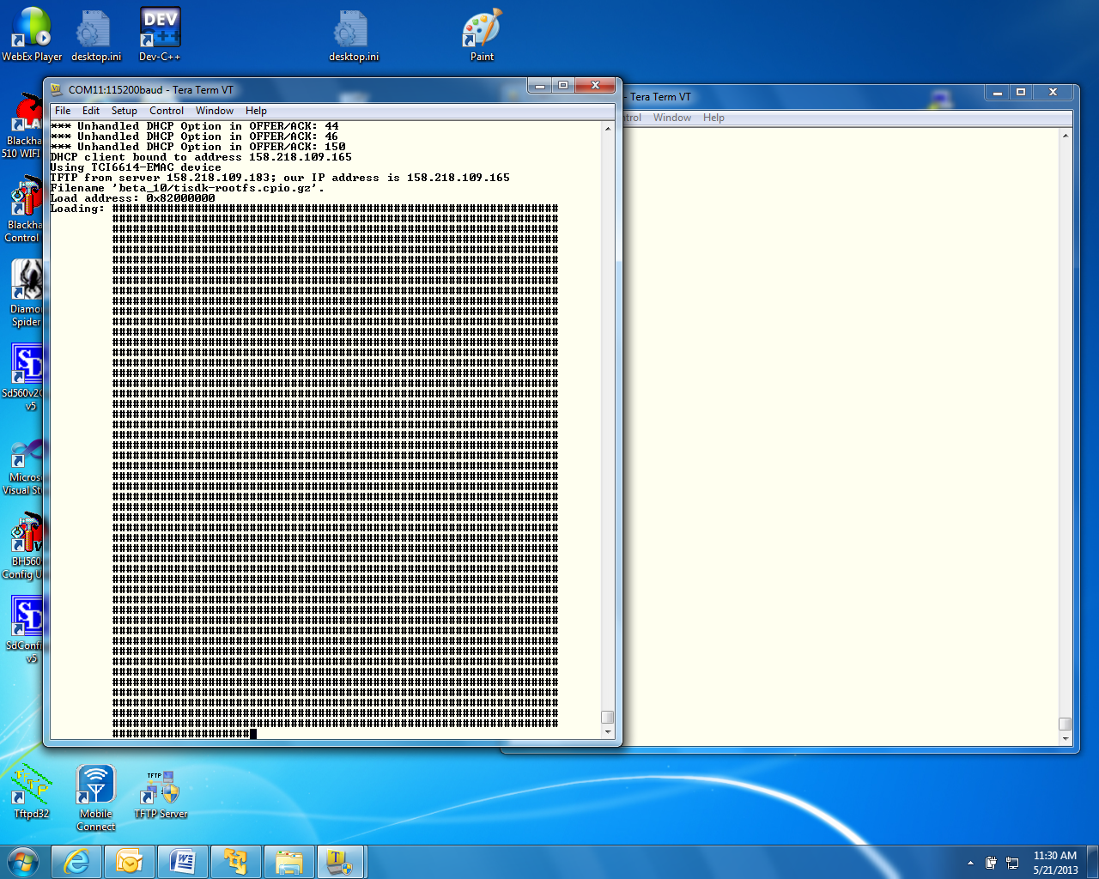

1. When booting ends, login as **root** (no password)

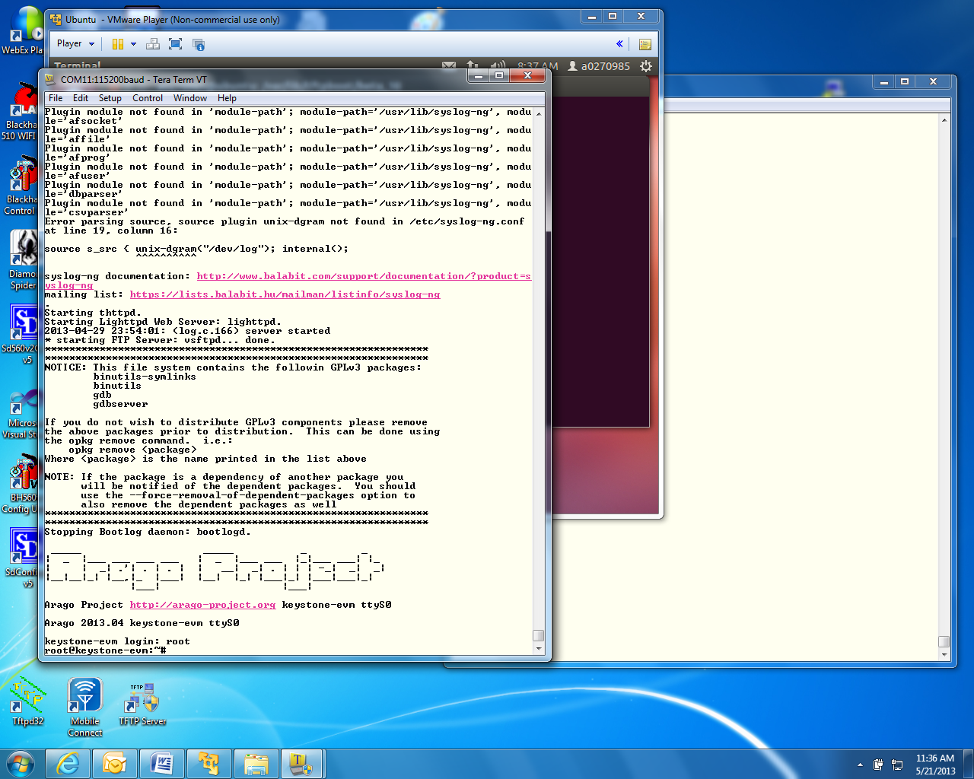

1. After you login as root, run the hello world program **./hello** and look for the hello world response

# Lab 2: Build a New ARM Program

## Projects and Source Code

All projects and source code are available on the Ubuntu server. The directory **/global/Projects** has two sub-directories:

* **/ARM** contains ARM projects
* **/DSP** contains DSP projects

NOTE: When the DSP projects are built using CCS on the student PC, projects should be moved via Samba or FTP from the server to the student laptop.

## Purpose

The purposes of this lab are:

1. To demonstrate how to build a simple ARM program using all cross compiler tools on Ubuntu server.
2. Build a new file system and load the net file system to the EVM
3. Run the built code

NOTE: In this Lab, the arago-console-image-k2hk file system is used.

### Task 1: Modify the File System

First, you will modify the arago-console-image-k2hk file system

Modifying the file system involves three steps:

1. First, a new main function is developed. Using the cross compiler tools on Ubuntu, the function is compiled and an executable is built.
2. Next, the arago-console-image-k2hk compressed file system is unzipped and de-compressed into a temporary directory, and the new executable that was built in the previous step is added.
3. Last, the new file system is compressed, zipped, and moved to the tftp directory. The u-boot updates name_fs, the name of the filesystem. The EVM is then booted, the new program is executed, and produces the expected results.

### Task 2: Retrieve Example Simple Code

1. The example code myHello.c is located on the Ubuntu server in **/global/Projects/ARM/myHello** directory
2. Copy this file to the student directory **/home/studentN/temp**

NOTE: If the temp directory does not exist, create it as follows:

* **cd ~** takes you to the home directory
* **mkdir temp**
* **cd temp**
* **sudo cp /global/Projects/ARM/myHello/myHello.c .**

1. For a system that is outside of the TI fire wall, **studentStartOutsideTI.sh** is a script that defines all the paths and exports for each individual user. The user must call this script for each new terminal:  
     
   Source: **/global/scripts/studentStartOutsideTI.sh**
2. For system inside of TI firewall, **studentStartInsideTI.sh** is a script that defines all the paths and exports for each individual user.   
     
   Source: **/global/scripts/studentStartInsideTI.sh**
3. The Linaro toolchain and all other shared software are installed on the Ubuntu server in directory **/tiTools/.** A path to the Linaro tool chain is defined in the script above.
4. Before compiling, look at the source code of myHello.c. You can modify it, add printf or any other C instruction that you like.

### Task 3: Build the Executable

1. To use the cross compiler to build the executable, use the following command:   
     
   **arm-linux-gnueabihf-gcc -o myHello –g myHello.c**  
     
   The cross compiler tools will compile the file and build an executable called **myHello** in the same directory.
2. To verify that the compilation was done for the ARM processor and not for the native Intel (or other) processors do the following:  
     
   **file myHello**
3. The results should show the ARM architecture:   
     
   **“myHello: ELF 32-bit LSB executable, ARM, version 1 (SYSV), dynamically linked (uses shared libs), for GNU/Linux 2.6.31, BuildID[sha1]=0x953dac672e7159d481d5a6d3bbb5356e5f870d21, not stripped”**

### Task 4: Unzip and Decompress the File System & Add New Executable

The compressed file system **arago-console-image-k2hk-evm** has a cpio.gz compression. You will build a new file system in the student home directory.

1. Copy the current compressed file system to the new directory:

**sudo cp /tftpboot/studentN/ arago-console-image-k2hk-evm.cpio.gz .**

1. Unzip the compressed file system

**sudo gzip –d arago-console-image-k2hk-evm.cpio.gz**

1. Uncompress the file system from the cpio file. This operation builds the complete file system.   
     
   **sudo cpio –i –F arago-console-image-k2hk-evm.cpio**
2. Remove arago-console-image-k2hk-evm.cpio

**sudo rm arago-console-image-k2hk-evm.cpio**

1. The file system resides in the temp directory. Copy the executable that was built previously (myHello) into the **usr/bin** directory in the file system. The complete path is **/home/studentN/temp/bin**

**sudo mv myHello /home/studentN/temp/bin/.**

**sudo mv myHello.c /home/studentN/temp/bin/.**

### Task 5: Compress and Zip the New File System

1. The next step is to compress the file system back into a new file system. This is done by piping all the directories and the files in the file system into the cpio zipped format. **The resulted compressed file system must reside in one directory above temp**. From the temp directory (/home/studentN/temp) do the following:

**sudo find . | sudo cpio –H newc –o –O ../myArago.cpio**

**cd ..**

**sudo gzip myArago.cpio**

1. The resulting file is **myArago.cpio.gz** This file should be copied to the student’s TFTP directory:

**sudo cp myArago.cpio.gz /tftpboot/studentN/.**

1. At this point, studentN has a new file system: **myArago.cpio.gz**
2. The user should change the environment variable **name_fs** in the EVM U-BOOT to **myArago.cpio.gz**

### Task 6: Reboot the EVM and Run the New Program

1. Reboot the EVM and stop the U-BOOT before it starts loading.
2. Change **name_fs** to the new filesystem  
     
   **setenv name_fs myArago.cpio.gz**
3. Enter **saveenv**
4. Enter **boot**
5. After boot, login as a **root**
6. Run myHello  **/bin/myHello**
7. Observe the results.

# Lab 3: Boot Using NFS-mounted File System

## Purpose

The purpose of this lab is as follows:

1. Demonstrate how to boot the EVM when the file system resides on a different server that is mounted on the EVM.
2. Develop code on the EVM and use the native gcc tools to build a debuggable executable.
3. Use gdb debugger to debug the developed code.

### Task 1: Build a File System on a Linux Host, Use the NFS Server

The NFS server is installed on the Ubuntu server in the directory /opt/filesys. Each student has a sub-directory where he or she builds the file server, and the Uboot is configured to reach this directory for each student. The file system to be mounted should be built on the local Ubuntu machine.

1. Change the directory into the NFS mount private directory for studentN **/opt/filesys/studentN** (where N is the student number).
2. Copy a tar version of the compressed file system **tisdk-rootfs-k2hk-evm.tar.gz** into **/opt/filesys/studentN**. This file system has the complete TI LINUX applications.

**tisdk-rootfs-k2hk-evm.tar.gz** is part of the release in the images directory, currently in **/tiTools/MCSDK_X_Y_Z/mcsdk_linux_X_Y_Z/images**  
  
NOTE: The release version shown here may not be the same as the one on your system)

1. Change the directory:  
   **cd /opt/filesys/student**
2. Copy the image:  
   **sudo cp /tiTools/MCSDK_X_Y_Z/mcsdk_linux_X_Y_Z/images/tisdk-rootfs-k2hk-evm.tar.gz .**
3. Untar the file system:  
   **sudo tar zxf tisdk-rootfs-k2hk-evm.tar.gz**
4. Remove the original compressed file:  
   **sudo rm tisdk-rootfs-k2hk-evm.tar.gz**

### Task 2: Configure U-BOOT to Mount the File Server and Boot

1. Power cycle the EVM.
2. In the ARM Tera Term, stop the autoboot.
3. Use the instructions in Lab 1 to set the following environment variables:

|  |  |
| --- | --- |
| **Variable** | **Value** |
| **nfs_serverip** | **192.168.0.100** |
| **boot** | **Net** |
| **nfs_root** | **/opt/filesys /studentN where N is the student number** |
| **args_net** | **setenv args_net 'setenv bootargs ${bootargs} rootfstype=nfs root=/dev/nfs rw nfsroot=${nfs_serverip}:${nfs_root},${nfs_options} ip=dhcp'** |

1. Save the new environment variables:

**saveenv**

1. Boot the EVM.

### Task 3: Build a New C Program in the File System and Debug It

1. After login as root in the ARM terminal you are in root home directory. Create an application directory:  
   **mkdir applications**
2. Change directory to applications: **cd applications**
3. In the server window, copy **myHello.c** from **/global/Projects/ARM/myHello** to the mounted applications directory of root **/opt/filesys/studentN/home/root/applications**

**sudo cp /global/Projects/ARM/myHello/myHello.c /opt/filesys/studentN/home/root/applications/.**

1. Back in the EVM terminal, locate the gcc native compiler and verify that it exists:  
   **which gcc**

Note: The response should be **/usr/bin/gcc**

1. Compile and build the application similar to the method used in the previous lab, but add the debug flag (**-g**) to the command and use the native gcc  
   **gcc –g -o myHello myHello.c**
2. Make sure that **myHello**.c and **myHello** are both in the applications directory:  
   **ls –ltr myHello\***
3. Start a debug session:  
   **gdb myHello**
4. Simple gdb commands:
   * **list** see the source
   * **b** set a break point
   * **r** run to the break point
   * **s** step
   * **n** next (step over)
   * **c** run to the next breakpoint
   * **finish** end
   * **delete n delete breakpoint at line n**
5. There are many gdb quick guides on the Web. Here are URLs to two of them:

<http://condor.depaul.edu/glancast/373class/docs/gdb.html>   
  
<http://darkdust.net/files/GDB%20Cheat%20Sheet.pdf>

1. Put some break point, look at the source (using the list or l command), run to breakpoint, do next and so on and so forth.

# 

# Lab 4: Boot Using USB Flash Drive

## Purpose

The purpose of this lab is to demonstrate how to boot the EVM from a USB flash drive. The Kernel, monitor, and device tree reside on one partition of the USB. The file system resides on a second partition.

NOTE – USB boot is not available on release 2 and 3 of the EVM unless they were changed to supply the USB with power. Release 1.1 of the EVM has USB power.

### Task 1: Preparing the USB

NOTE: This procedure may already be done. In that case the instructor will provide pre-prepared USB memory stick. Preparing the USB requires Ubuntu host to be physically available for USB stick. So if the students have to prepare USB, it will be done one after another on the Ubuntu host.

#### Step 1: Install GParted On Ubuntu Host

Used GParted 0.11.0 for this test. So exact steps may vary if version is different

$sudo apt-get install gparted

#### Step 2: Partition the Device

Before you start partitioning the USB, verify what /dev are currently connected so it will be easy to identify the device name of the USB.

##### Prepare the USB for New Partitions

* 1. **Do not** connect the USB stick to the server.
  2. Start GParted **sudo gparted**
  3. The following is a screen shot from GParted. In the upper right corner, click the small arrow and verify what devices are connected and their respective sizes.  
       
     In the screen shot below, there is a single device /dev/sda with size of 238.47 GB

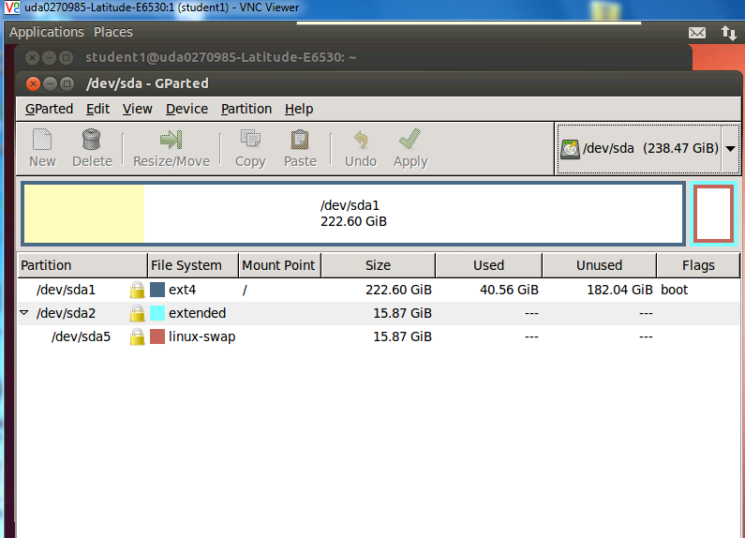

* 1. Quit GParted (GParted -> Quit), insert the USB stick into a USB port, and start GParted again. This time the device list will show a new device. The new device /dev/sdb has size of 982MB. This is the USB stick that needs reformatting. See the screen shot below:

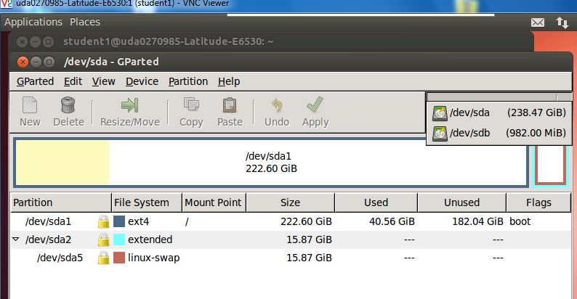

* 1. Select the new device.  
     In this case, /dev/sdb (NOTE: If the server has multiple disks, the name may be different)
  2. Unmount the device: **Partition -> Unmount**
  3. If there is existing partition, delete it: **Partition -> Delete**

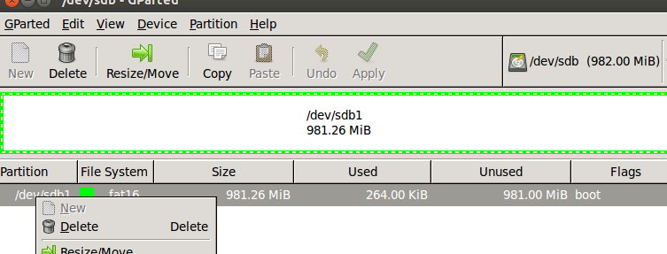

##### Add Two New Partitions

After deleting the old partition, the partition and filesystem status now shows as unallocated. You can now start building two new partitions:

1. partition 1 for boot images
2. partition 2 for rootfs

###### Create fat32 Partition for Boot (contains boot images)

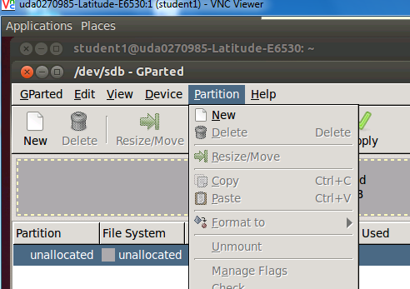

1. Create a new partition: **Partition -> New**
   * New size = 32MiB
   * File system = fat32
   * label = boot
   * Keep rest of the fields default
2. Click add to add the new partition
3. Select the partition you just created and format it: **Partition -> Format to**
4. Select fat32 format

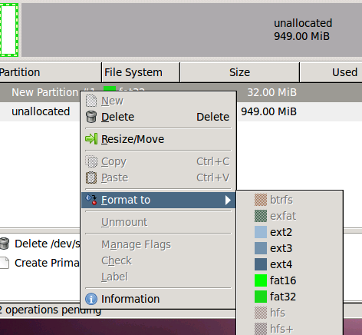

###### Create ext4 Format for rootfs (contains root filesystem)

1. Select the unallocated partition and create a new one: **Partition -> New**   
   * File system = ext4
   * label = rootfs
   * Keep rest of the fields default
2. Click add to add the new partition
3. Select the partition you just created and format it: **Partition -> Format to**
4. Select ext4 format
5. Apply the changes and Quit:

* Edit -> Apply All Operations
* GParted -> Quit

#### Step 3: Copy Images and rootfs Files to Partitions

Assume that the USB device name is /dev/sdb (if different name, change the instructions accordingly).

1. Unmount if the devices are auto mounted.

sudo umount /dev/sdb1

sudo umount /dev/sdb2

1. Copy images to partition #1 (boot). First partition is mounted to /mnt/test

sudo mount -t vfat /dev/sdb1 /mnt/test

1. Change directory to image release directory

cd /tiTools/MCSDK_X_Y_Z/mcsdk_linux_x_y_Z/images

1. Copy the kernel, device tree and monitor to the first partition

sudo cp skern-k2hk-evm.bin /mnt/test/

sudo cp uImage-k2hk-evm.dtb /mnt/test/

sudo cp uImage-keystone-evm.bin /mnt/test/

ls /mnt/test

**skern-k2hk-evm.bin uImage-k2hk-evm.dtb uImage-keystone-evm.bin**

sudo umount /dev/sdb1

1. Copy rootfs files to partition #2 (rootfs). Change directory to the student directory where the NFS mounted filesystem was built previously.

cd /opt/filesys/studentN

Where N is the student number.

sudo mount -t ext4 /dev/sdb2 /mnt/test

cd ..

sudo cp -r studentN/* /mnt/test

ls /mnt/test/

bin boot dev etc home init lib lost+found media mnt proc sbin srv sys tmp usr var

sudo umount /dev/sdb2

### Task 2: Reboot the EVM

#### Configure U-BOOT Environment Variables

1. Insert USB flash drive to usb slot on EVM and Power ON EVM
2. Type the following commands to setup the env for usb boot:

setenv boot usb

setenv args_usb 'setenv bootargs ${bootargs} rootfstype=ext4 root=/dev/sda2 rw ip=dhcp'

setenv init_usb 'usb start; run set_fs_none args_all args_usb'

setenv get_fdt_usb 'fatload usb 0:1 ${addr_fdt} ${name_fdt}'

setenv get_kern_usb 'fatload usb 0:1 ${addr_kern} ${name_kern}'

setenv get_mon_usb 'fatload usb 0:1 ${addr_mon} ${name_mon}'

Make sure that name_mon, name_kern, and name_fdt are the same as were loaded into  
partition 1. In our case these are the expected values:

* name_fdt=uImage-k2hk-evm.dtb
* name_kern=uImage-keystone-evm.bin
* name_mon=skern-k2hk-evm.bin

If any of the above values are not correct, use **setenv** to configure the correct value.

1. Type **saveenv**
2. Type **boot**

Boot takes about 1 minute

1. Login as root and run the program that was developed for the NFS case (myHello)
2. Change the source code myHello.c (for example, add a printf saying that this is part of the USB boot)
3. Compile the new file and run it.

# Lab 5: Build, Run and Optimize DSP Project Using CCS

## Purpose

In previous labs, you developed and debugged an ARM program. The purpose of this lab is to develop and debug a multicore C66x program using CCS IDE. This lab has the following parts:

1. Using CCS, build a simple FIR project that runs on a single core.
2. Optimize the code by achieving software pipeline, understand what can prevent the compiler from generating software pipeline code.
3. Optimize execution by enabling cache.
4. Perform parallel processing of the code and observe multi-cores processing speed up.

CCS IDE is used to execute the lab.

Before starting, the EVM should be configured to no-boot mode. To do so, set the dipswitch (SW1) on the EVM to: 1 Off 2 Off 3 Off 4On

The EVM emulator is the mezzanine card on the top of the EVM. The mini USB cable should be connected to the mezzanine card and to a computer with CCS installed.

## Project Files

The following files are used in this lab:

* firMain.c
* firRoutines.c
* firTest.cmd
* firTest.h
* utilities.c
* Utilities.h
* firFilterLab.cfg

### Task 1: Build and Run the Project

1. FTP into the Ubuntu server and get all the files in directory **/usb/global/Projects/DSP/firFilter** into the local directory **c:\ti\labs\firFilter** on your PC. If this directory does not exist, create it.
2. Open CCS.
3. Create new project through the CCS menu item *File* 🡪 *New* 🡪 *CCS Project*.
4. Enter **firLab1**as a *Project Name*.
5. Click the check box to *Use default location.*
6. Set the *Family* to *C6000* and *Variant* to *Generic C66xxx Device*
7. Then press *Finish* to create the new project. See the screen shot.  
   NOTE: You will use the default location and not the location in the screen shot.

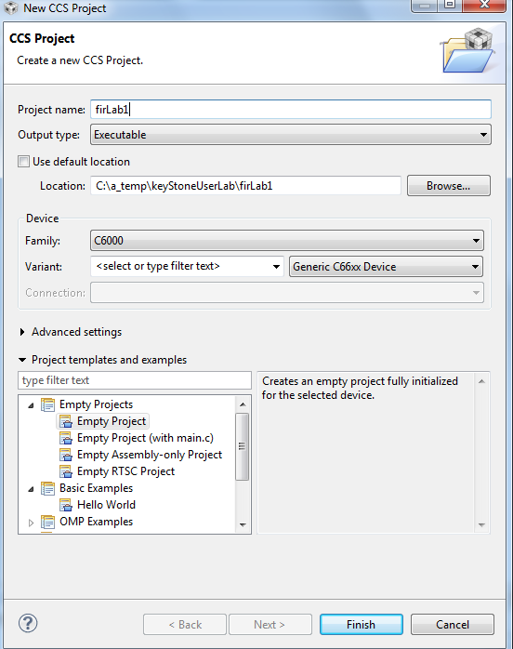

1. Then in the *Project Explorer* view, right-click on the newly-created *firLab1* project, and click on *Add Files…*
2. Browse to **C:\ti\labs\firFilter**, select all the files in this directory, and click *Open*. When prompted how files should be imported into the project, leave it as default of *Copy File.* If you defined the new project with **main.c,**remove the **main.c** file that may be created.
3. As soon as the file **firFilter.cfg** is imported into the project, CCS will ask you to enable RTSC support. See the screen shot below. Select *Yes*. Note, if CCS does not ask you to enable RTSC, rename the cfg file to some other name, and rename it back to firFilterLab.cfg

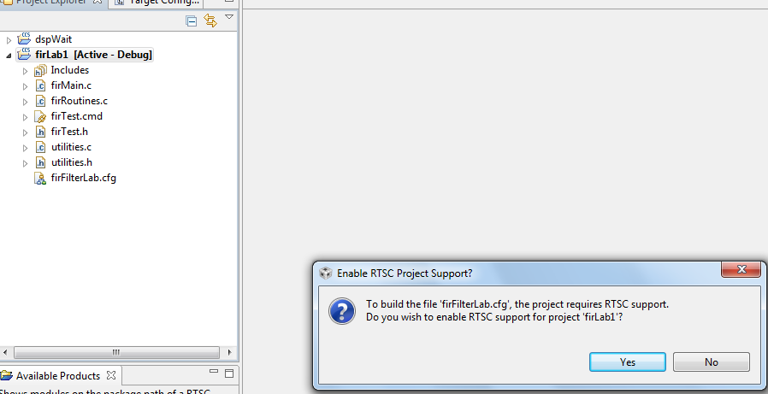

1. Open Project Properties and select general->RTSC. Look at the RTSC modules that are selected in the screen shot below and make sure that you select ONLY the same RTSC modules (or packages). When a project starts, RTSC attempts to include all the modules in the release. So unselect any module that is not in the screen shot.  
     
   NOTE: The TARGET CONTENT BASE should reflect the location of CCS on your system.

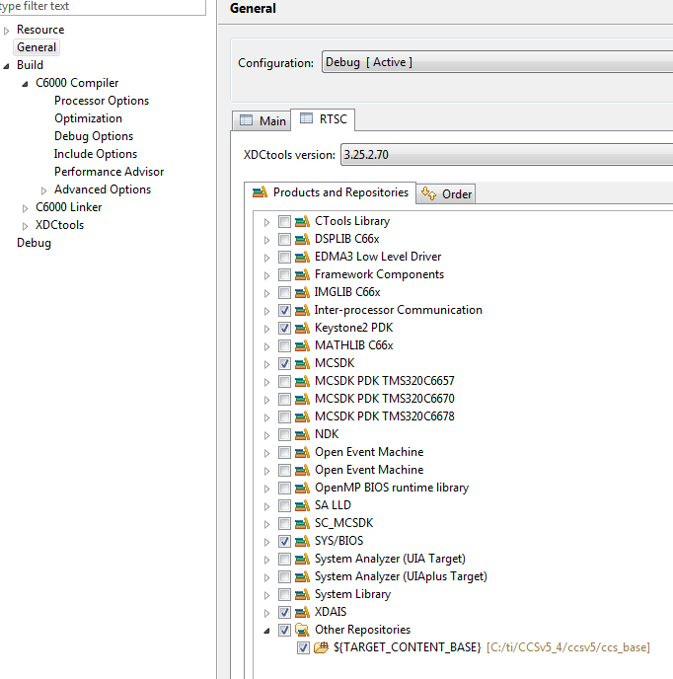

1. If the XDAIS product does not appear in your screen (usually in CCSv6) add the XDCtools repository to the list. Find the location of XDCtools in the MCSDK release (in my case it is **C:\ti\MCSDK_X_Y_Z\xdctools_X_Y_Z\packages**). Make sure you have the packages and add it to the product.

**Property->RTCS->Add** and add the path to the packages

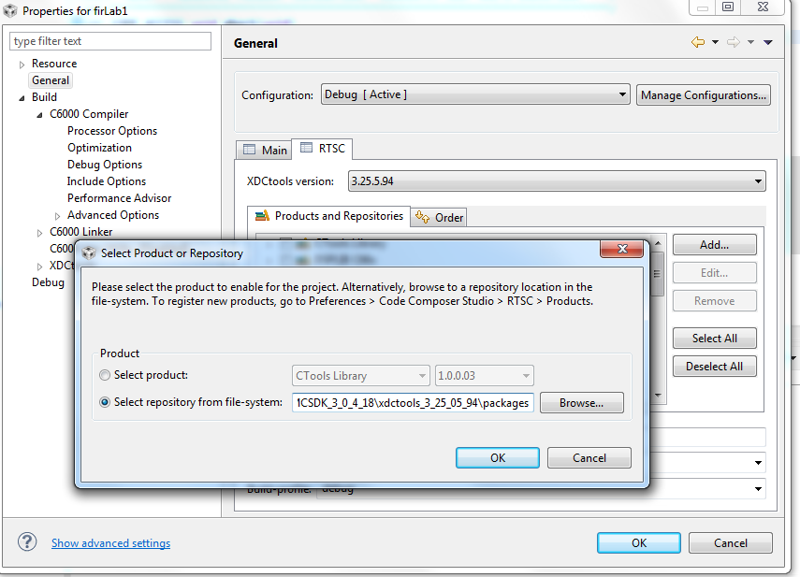

1. Click on the platform tab and select **ti.platform.evmTCI6638K2K**platform as shown in the next screen shot.

NOTE: RTSC projects require the user to select three types of information.

* The device family in the CCS create page determines what core is used and thus what version of the compiler should be used (different cores have different intrinsic functions).
* The platform that is defined here determines the memory configuration of the core.

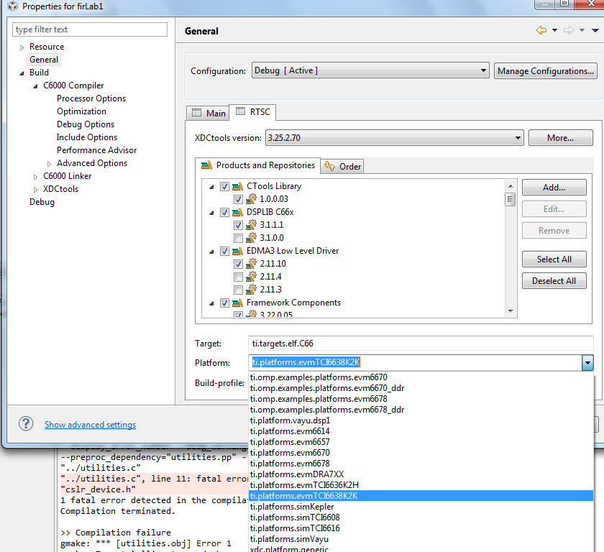

1. Add csl include files location. On your laptop, find the directory: **\pdk_keystone2_X_Y_Z\packages\ti\csl** and add this directory to the include options property of the project. On my system the location of the file is in: **C:\ti\MCSDK_X_Y_Z\pdk_keystone2_X_Y_Z\packages\ti\csl**See the following screen shot:

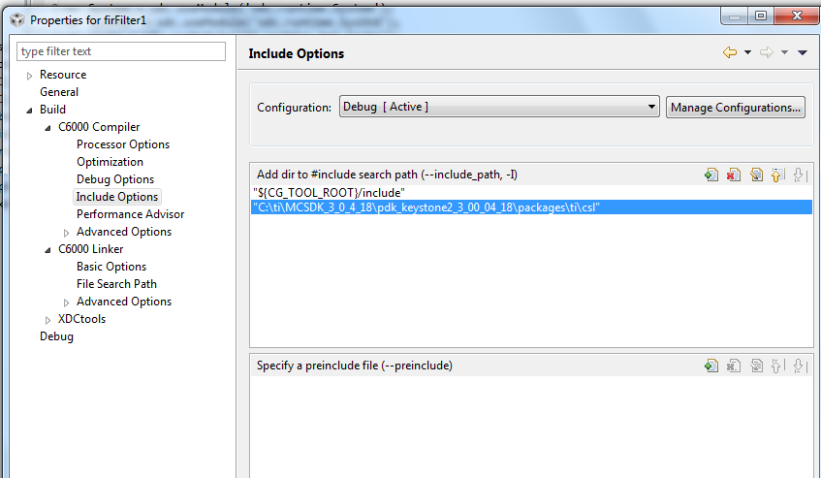

1. Add the include file **cslr_device.h** at the above screen. Select a pre-include file and add **cslr_device.h**
2. Add a path to **cslr_device.h** similarly to the above instructions. The path is **pdk_keystone2_X_Y_Z\packages\ti\csl\device\k2k\src**
3. Add the CSL library and the path to the CSL library to the project properties. Libraries and paths to libraries are defined in the linker tab of the properties under file search path section.  
     
   The following is a screen shot from my system. You have to modify the path to the library based on the location of your release. Note: There are other ways to define the library and the paths as relative to the release location.

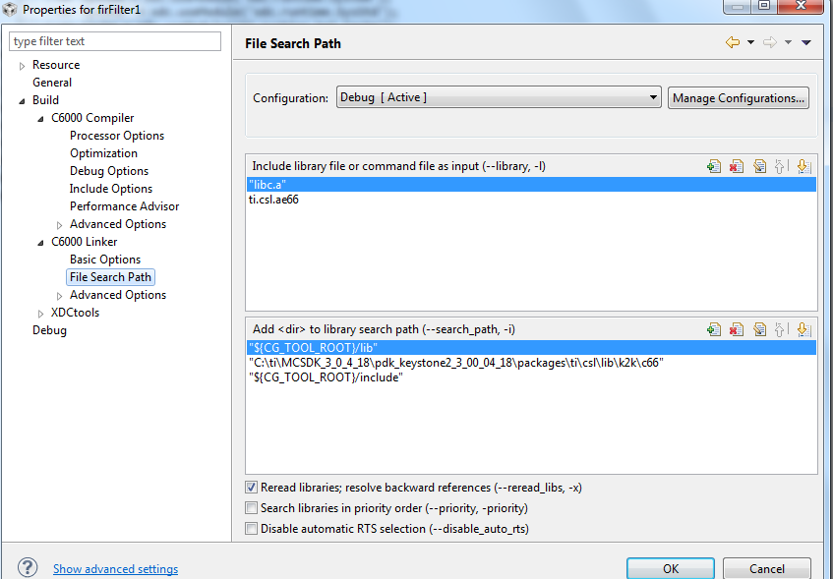

1. Right click on the project name and select *rebuild*. If the build goes correctly, you will see the following in the console window.  
     
   NOTE: Look at the debug directory to ensure that the file **firLab1.out** is there. Ignore any warnings.

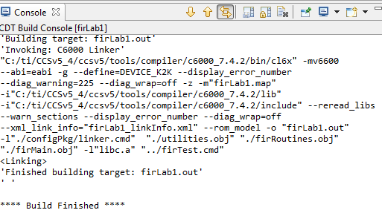

1. Examine the code in **firMain.c**. There are five cases, but only case 1 is not commented out.
   1. DSP 0 generates input data (**inputData**) and a set of filter coefficients (**filterCoef**)
   2. Depending on the case, a set of fir filters is applied to the data and the results are written to the out file (**outputFilter**).
   3. A set of timer registers (**TSCL** and **TSCH**) measure the execution time of the fir filter.
   4. The standard **printf** function prints the results on the console.

### Task 2: Define the Target

In this lab, the DSP code is run from no-boot mode. The no-boot mode requires setting the dipswitch SW1 of the EVM to: 1 Off 2 Off 3 Off 4 On.  
  
Since no-boot mode is chosen, the device configuration (DDR configuration, PLL configuration and so on) must be done in a gel file.

#### Create a New Target in CCS

NOTE – the paths and other variables that are defined in this document may not reflect exactly the directory structure on your system. Use common sense and search to find the exact paths.

1. Create a new target configuration:
   1. Select the CCS menu option *View 🡪 Target Configurations*.
   2. Select *User Defined*.
   3. Right-click and select *New Target Configuration*.
2. Enter the name of the new target configuration in the *File Name:* text box.
   1. Set the File name based on the EVM model, *<model>.ccxml*  
      For example, ‘TCI6638.ccxml’
   2. Leave the *Location* the default value:  
      “C:\Documents and Settings\student\ti\CCSTargetConfigurations”
   3. Click the *Finish* button. The .ccxml file will now open in a GUI-based view with the *Basic* tab active.
3. Define the new target configuration by selecting the connection type in the *Basic* Tab.
4. The *Connection* drop-down menu identifies the emulator type. For example, ‘Texas Instruments XDS2xx USB Emulator.”
   1. *Board or Device* identifies the TI processor device, set it to 6638 and select TCI6638K2H
   2. Under *Save Configuration*, click the *Save* button.
5. Configure setup in *Advance* Tab
   1. Click the *Advanced* tab at the bottom of the screen.
   2. Select Core 0 on the target device:
      * *TCI6638_0* 🡪 *IcePick_C_0* 🡪 *Subpath_1* 🡪 *C66xx_0*
   3. You will now see a sub-window called *Cpu Properties* that allows you to choose an *initialization script*.
   4. Locate the appropriate GEL file, then click *Open*:
6. Depending on your CCS version select the gel file. For example, for CCSv5 that is installed in directory c:\ti\CCS_5_5 the gel file is located at   
     **C:\ti\CCS_5_5\ccsv5\ccs_base\emulation\boards\xtcievmk2x\gel\** **xtcievmk2x.gel**

Note, if the CCS that you use is located in a different directory, change the path accordingly

1. Repeat the process for all C66x cores (*C66xx_1, C66xx_2, … C66xx_7*)
2. Click the *Save* button.

### Task 3: Connect to the EVM

1. Click the Open Perspective (available at the right top corner of the CCS window).
2. Switch to the Debug Perspective by selecting the CCS menu option Window 🡪 Open Perspective 🡪 CCS Debug.
3. Select the CCS menu option View 🡪 Target Configurations. Select the target configuration you created
4. Launch the target configuration as follows:
   1. Select the target configuration .ccxml file.
   2. Right click and select *Launch Selected Configuration*.
5. This will bring up the *Debug* window. NOTE: This may take some time, but you will eventually see all the device cores.
   1. Select all C66x cores (select + Ctrl)
   2. Right click and choose *group cores*.
   3. Select the group, then right click and select *Connect Target.*

### Task 4: Load and Run CASE 1

1. Select the core group and load the .out file created earlier in the lab.
   1. Select the CCS menu option *Run* 🡪 *Load* 🡪 *Load Program*
   2. Click *Browse project…*
   3. Select *firLab1.out* by unwrapping the *firLab1->Debug* and click *OK.*
   4. Click *OK* to load the application to the target (all Cores).
2. Run the application by selecting the CCS menu option *Run* 🡪 *Resume*.
3. A successful run should produce a console output as shown below. Record the cycles time:

[C66xx_0] start generating input data

finish generating input data

case 1 -> time consumed By core -> 0 610749952.000000

**Issues to think about:**

Look at the function CACHE_disableCaching ((Uint8) 144) which disables cache-ability for memory region. What memory region is it?

1. See Table 4-20 in the C66 CorePac User’s Guide <http://www.ti.com/lit/ug/sprugw0c/sprugw0c.pdf>

Look at the User Guide, the code, and the map file.

### Task 5: Use Optimization and Disable Symbol Debug for the fir Filter Routine

As the project is still in development/debug state, there is no optimization and full debug support. The next step is to optimize the fir filter and disable the debug information. However, leave the other parts of the project without optimization and with full debug support. The properties for the file firRoutines.c will be changed. No other file will be effected.

1. In the project explorer, select the file **firRoutines.c** and right click. Open the properties dialogue window as shown below.
2. Select *build->optimization*. In the dialogue window set optimization to 3
3. From the debug options dialogue select *suppress all symbolic debug generation* from the pull-down menu.

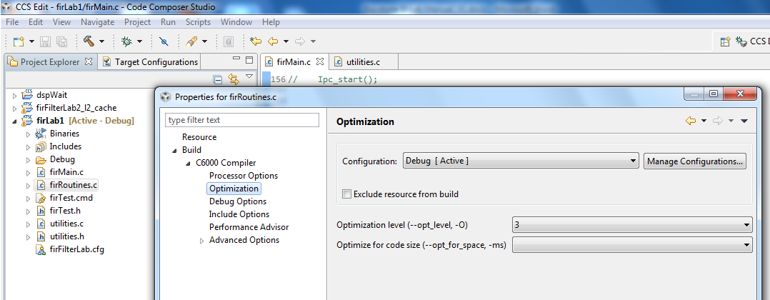

1. From the *build ->C6000 compiler -> Advanced Debug,* select *Assembly options* and check *Keep the generated assembly language (.asm)* file as shown in the screen shot below.

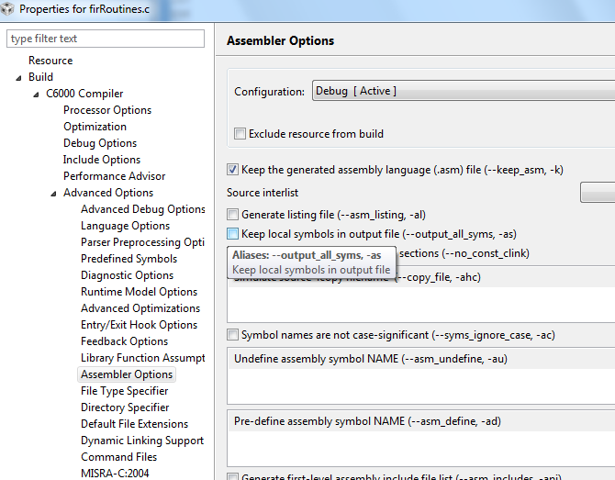

1. Click OK and rebuild the project. Load and run.
2. A successful run should produce a console output as shown below. Record the cycles time:

**Start generating input data**

**Finish generating input data**

**Case 1: Time consumed by core -> 0 500579008.000000**

**QUESTION:**

Is the code really optimized? Only 15% improvement.

1. Look at the assembly file firRoutines.asm in the debug directory and search for the function firRealFilter. Look for the loop and see if the compiler could get software pipeline

What is the reason that the loop does not qualify for software pipeline?

### Task 6: Optimize Software Pipeline

The reason why the fir filter loop is not qualified for a software pipeline is because it calls myMultiply. The next task is to inline this function. myMultiply is an artificial function (i.e., no one will develop this function in real code). So it is easy to “inline” it. Look at the definition of myMultiply in the utilities.c file and inline it.

1. Change the function firRealFilter by inline myMultiply function
2. Save and build the project. Load and run.
3. A successful run should produce a console output as shown below. Record the cycle time:

**start generating input data**

**finish generating input data**

**case 1 -> time consumed By core -> 0 273086080.000000**

1. Next, tell the compiler the minimum number times that each loop will be executed. The filter size in this program is 8. Assume that the filter size will always be more than 4 and divided by 4, so adding a pragma( **#pragma** MUST_ITERATE(4,,4); ) will tell the compiler that the inner loop must be performed at least 4 times and the number of iterations is divided by 4.
2. The outer loop presents the size of the output vector. The number of elements is 16K, but eventually we would like to run it on all 8 cores, so each core will have about 2K element. It is enough if we tell the compiler that the number of elements is more than, say 64. However, if you look carefully, you will notice that the number of output results is 16K – filter size + 1, so this is an odd number. You can tell the compiler that the number of elements is more than 64. In that case use something like (**#pragma** MUST_ITERATE(64,,1); ) or, if you agree to ignore the last fake result, you can tell the compiler (**#pragma** MUST_ITERATE(4,,2); ))
3. Add the two pragma directives before the two loops (internal and external) in the function save and build.
4. If the external loop is **pragma** MUST_ITERATE(64,,1)

**start generating input data**

**finish generating input data**

**case 1 -> time consumed By core -> 0 221407008.000000**

1. If the external loop is **pragma** MUST_ITERATE(64,,2);

**start generating input data**

**finish generating input data**

**case 1 -> time consumed By core -> 0 221306848.000000**

**QUESTION:** To summarize the code optimization section, complete the following table:

|  |  |  |
| --- | --- | --- |
| **Optimization Technique** | **Cycles** | **Improvements Compared with Previous Line** |
| No Optimization |  |  |
| Compiler optimization 3, no symbolic debug |  |  |
| Software Pipeline |  |  |
| Adding pragma must iterate |  |  |

### Task 7: Enable the Cache

Enabling the cache is done in CASE 2. Un-comment the line **#define CASE_2** above the **main()** in **firMain.c**

**QUESTION:**

What instruction(s) enable the cache?

1. The function CACHE_enableCaching ((Uint8) 128) ; was discussed in Task 4. The function CACHE_setL2Size ((CACHE_L2Size) 4); is part of the file csl_cachAux.h in the \MCSDK_3_14\pdk_keystone2_3_00_02_14\packages\ti\csl directory. Note, version number and location of MCSDK may be different for your setting.
2. Un-comment the line **#define CASE_2** in **firMain.c**
3. Save, build, load and run. The results will look like the following:

**start generating input data**

**finish generating input data**

**case 1 -> time consumed By core -> 0 221223008.000000**

**case 2 -> time consumed By core -> 0 7491409.000000**

**QUESTION: Complete the table.**

|  |  |  |
| --- | --- | --- |
| **Optimization Technique** | **Cycles** | **Improvements compare with previous line** |
| No Optimization |  |  |
| Compiler optimization 3, no symbolic debug |  |  |
| Software Pipeline |  |  |
| Adding pragma must iterate |  |  |
| Enabling cache |  |  |

**QUESTION: What are the most important steps to optimize code running on a single core?**

### Task 8: Running in Parallel on Multiple Cores

Multiple cores are enabled in CASE 3 (2 cores), CASE 4 (4 cores) and CASE 5 (8 cores).

Un-comment the lines **#define CASE_3 #define, CASE_4** and **#define CASE_5** above the **main()** in **firMain.c**

1. Un-comment the line #define CASE_3 #define CASE_4 #define CASE_5 in firMain.c
2. Save, build, load and run. The results will be look like the following:

**finish generating input data**

**case 1 -> time consumed By core -> 0 288423616.000000**

**case 2 -> time consumed By core -> 0 7493824.000000**

**case 3 -> time consumed By core -> 0 3680093.000000**

**[C66xx_1] case 3 -> time consumed By core -> 1 3678251.000000**

**[C66xx_0] case 4 -> time consumed By core -> 0 1839643.000000**

**[C66xx_1] case 4 -> time consumed By core -> 1 1838608.000000**

**[C66xx_2] case 4 -> time consumed By core -> 2 1839438.000000**

**[C66xx_3] case 4 -> time consumed By core -> 3 1836440.000000**

**[C66xx_0] case 5 -> time consumed By core -> 0 918711.000000**

**[C66xx_1] case 5 -> time consumed By core -> 1 921884.000000**

**[C66xx_2] case 5 -> time consumed By core -> 2 921973.000000**

**[C66xx_3] case 5 -> time consumed By core -> 3 920785.000000**

**[C66xx_6] case 5 -> time consumed By core -> 6 922374.000000**

**[C66xx_4] case 5 -> time consumed By core -> 4 923078.000000**

**[C66xx_5] case 5 -> time consumed By core -> 5 921646.000000**

**[C66xx_7] case 5 -> time consumed By core -> 7 920075.000000**

For each case, the total time that is consumed to perform the FIR filter is the maximum time of all the cores.

**QUESTION: Complete the table**

|  |  |  |  |  |
| --- | --- | --- | --- | --- |
| **Case** | **Cycles per core** | **Execution cycles (this is the cycles of the core with the highest cycles count)** | **Accumulate execution time for all the cores** | **Penalty of the accumulation execution time compared to single core (CASE 2)** |
| Case 2 – single core |  |  |  |  |
| Case 3 – 2 cores |  |  |  |  |
|  |
| Case 4 – 4 cores |  |  |  |  |
|  |
|  |
|  |
| Case 5 – 8 cores |  |  |  |  |
|  |
|  |
|  |
|  |
|  |
|  |
|  |

**QUESTIONS:**

1. What is the purpose of the function **waitBarrier(barrier_1, coreNum, jointNumber)**? What would happen if the function is commented out?
2. Try to comment out the function (3 places) and see what happens.
3. What is the purpose of the function **waitAboutNSeconds(10)** inside the function **waitBarrie**? What would happen if the function is commented out? Do you understand why?

1. Try to comment out the function and see what happens. Think about timing between cores.
2. Can you think about other (better) methods to synchronize the execution of all the cores?
3. Semaphores?, QMSS queues based solution?, openMP? .

# Lab 6: Load and Run DSP Code Using MPM Server

In this lab, you build a DSP project similar to the previous lab. Before starting, you should change the boot mode of the EVM back to boot mode. Set SW1 of the EVM back to 1 Off 2 Off 3 On 4 Off.

Read the instructions in Lab 3 to ensure that the EVM boots using NFS-mounted file system.

## Purpose

Building a DSP code that is managed by the ARM. The ARM will reset C66x Core 0, load it with an executable, run it, and retrieve the results.

## Project Files

The following files are used in this lab:

* **Main.c**
* **mpmsrv_keystone2_example1.cfg**

### Task 1: Build and Run the Project

1. FTP into the Ubuntu server and copy all the files that are in the directory **/global/Projects/DSP/mpm_example** into a local directory **c:\ti\labs\mpm_example** on your PC. If this directory does not exist, create it.
2. Open CCS.
3. Create new project through the CCS menu item **File 🡪 New 🡪 CCS Project**.
4. Enter **mpm_example**as a **Project Name**.
5. Click the check box to **Use default location***.*
6. Set the **Family** to**C6000**and**Variant**to **Generic C66xxx Device***.*
7. Then press **Finish**to create the new project.
8. Then in the **Project Explorer** view, right-click on the newly-created **mpm_example** project, and click on **Add Files…**
9. Browse to **C:\ti\labs\mpm_example**, select all the files in this directory, and click **Open**. When prompted how files should be imported into the project, leave it as default of **Copy File***.* If you defined the new project with **main.c**,remove the **main.c** file that may be created.
10. As soon as the file **mpmsrv_keystone2_example1.cfg** is imported into the project, CCS will ask you to enable RTSC support. Select Yes.
11. Open Project Properties and select general->RTSC. Look at the RTSC modules that are selected in the screen shot below and make sure that you select ONLY the same RTSC modules (or packages). When a project starts, RTSC attempts to include all the modules in the release. So unselect any module that is not in the screen shot.  
      
    NOTE: The TARGET CONTENT BASE should reflect the location of CCS on your system.

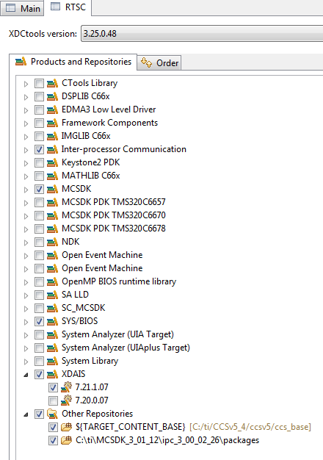

1. Click on the platform tab and select **ti.platform.evmTCI6638K2K**platform

NOTE: RTSC projects require the user to select three types of information.

* The device family in the CCS create page determines what core is used and thus what version of the compiler should be used (different cores have different intrinsic functions).
* The platform that is defined here determines the memory configuration of the core.
* To build the correct RTSC drivers, the device name should be defined. This is done by adding a predefined symbol with the device name. More about it later.

1. Right click on the project name and select *rebuild*. If the build goes correctly, you will see the following in the console window. NOTE: Look at the debug directory to ensure that the file **MPM_example.out** is there. Ignore any warnings.

**'Building target: MPM_example.out'**

**'Invoking: C6000 Linker'**

**"C:/ti/CCSv5_4/ccsv5/tools/compiler/c6000_7.4.2/bin/cl6x" -mv6600 --abi=eabi -g --display_error_number --diag_warning=225 --diag_wrap=off -z -m"MPM_example.map" -i"C:/ti/CCSv5_4/ccsv5/tools/compiler/c6000_7.4.2/lib" -i"C:/ti/CCSv5_4/ccsv5/tools/compiler/c6000_7.4.2/include" --reread_libs --warn_sections --display_error_number --diag_wrap=off --xml_link_info="MPM_example_linkInfo.xml" --rom_model -o "MPM_example.out" -l"./configPkg/linker.cmd" "./main.obj" -l"libc.a"**

**<Linking>**

**'Finished building target: MPM_example.out'**

**'**

**\*\*\*\* Build Finished \*\*\*\***

### Task 2: Using MPM to Load, Run and Observe Results

In this part, we assume that the EVM is boot in net mode, that is, the file system is on the server and it is mounted to the EVM as used in Lab3

1. Find the location where the out file resides. To do so find the outfile in the debug directory of the project, select the outfile and right click properties. Look at the location at the top of the open dialogue

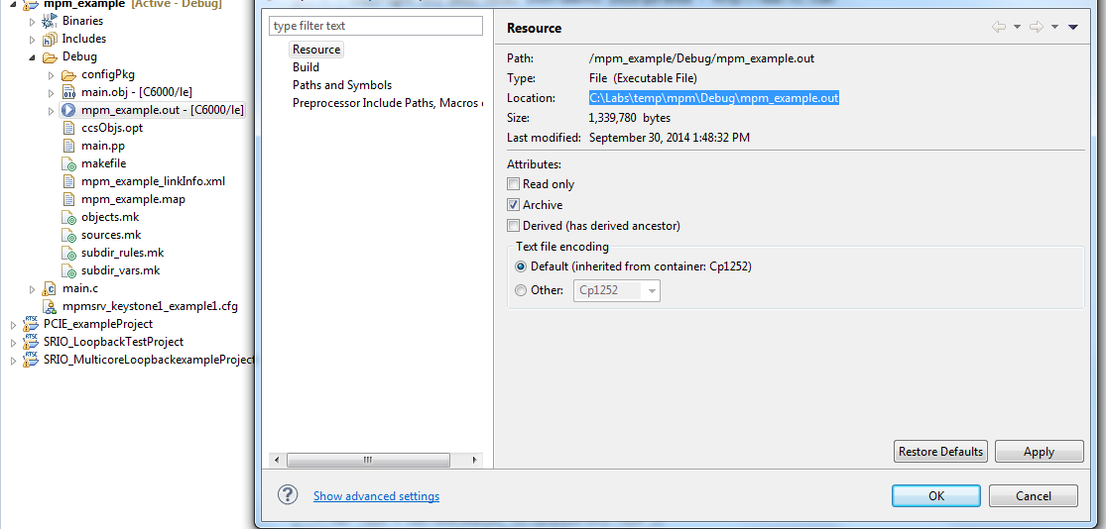

1. From the VNC navigate to you directory /opt/filesys/studentN
2. Change the permission of the bin subdirectory, do sudo chmod 777 bin
3. FTP the out file into the server to **/opt/filesys/studentN/bin** where N is the student number.
4. Reboot the EVM using NFS.
5. From the terminal login as **root**
6. **cd /bin**
7. Use MPM to reset, load, and run core 0 with **MPM_example.out** by using the following MPM commands:

**mpmcl reset dsp0**

**mpmcl load dsp0 MPM_example.out**

**mpmcl run dsp0**

1. After the end of run, look at the trace buffer printing by using the following command:

**cat sys/kernel /debug/remoteproc/remoteproc0/trace0**

1. Change the main.c file as you wish, build it again, ftp to the file system (step 7) load the code to a different dsp (use N here) and run it:

**mpmcl reset dspN**

**mpmcl load dspN MPM_example.out**

**mpmcl run dspN**

1. After the end of run look at the trace buffer printing by using the following command:

**cat sys/kernel/debug/remoteproc/remoteprocN/trace0**

# 

# Lab 7: ARM-DSP Co-working Using MPM & Shared DDR

In this lab, you build a DSP project that uses the DDR. Unlike the previous Lab where the code and the data were only in L2, in this lab some DDR is used by the DSP.

## Purpose

Building a DSP code that uses the DDR and is managed by the ARM.

## Linux and DSP Simple Memory Management

The previous project uses private L2 memory for program and data. This DSP project uses DDR. How does the system manage the DDR resources between the DSP and the ARM?

The Linux uses part of the DDR. So if a DSP program uses some of the DDR, it must tell the Linux. This is done in the U-BOOT environment.

To do it correctly, the user must follow the following steps:

1. Stop autoboot and look at the messages from the U-BOOT. It looks like the following:

**U-Boot 2013.01 (Oct 02 2014 - 00:16:34)**

**I2C: ready**

**Detected SO-DIMM [18KSF1G72HZ-1G6E2 ]**

**DRAM: 8 GiB (includes reported below)**

**NAND: 512 MiB**

**Net: K2HK_EMAC, K2HK_EMAC1, K2HK_EMAC2, K2HK_EMAC3**

**Hit any key to stop autoboot: 0**

The size of the DRAM is 8 GiB in this case. It can be different size, depending on the EVM revision and memory configuration.

1. TI software divides the total DRAM into two segments – Segment 0 with 2GB and segment 1 with 6GB. U-BOOT enables the user to define reserve one area in each segment for DSP usage. The DSP area (key word mem_reserve) is located at the end of the segment.
2. Now determine how much DRAM the DSP needs. Obviously it must be less than the total DRAM in the EVM. Assume that in segment 0 Linux uses 1536 M and the DSP will use 512MB. The user must tell the U-BOOT that 512MB is reserved for the DSP.
3. After stopping the autoboot, configure the memory that is assigned to the DSP (if it is not configured already).

**setenv mem_reserve 512M**

**saveenv and boot**

1. The memory that is reserved for the DSP is located at the end of the available memory. For the 2G DRAM case, available memory is between 0x80000000 and 0xffffffff, so the 512M reserved for the DSP start at address 0xE0000000 to address 0xffffffff
2. The first part of the project we will try to build the project without changing the platform and encounter an error
3. Next, you need to build the DSP code and ensure that it uses only the assigned DDR. One way to do this is by using direct addressing. We will use this method in the Lab.

## Building the Project with the Default Platform

### Task 1: Build and Run the Project

1. FTP into the Ubuntu server and copy all the files that are in the directory **/global/Projects/DSP/mpm_example_sum** into a local directory **c:\ti\labs\mpm_example_sum** on your PC. If this directory does not exist, create it. To ftp all files with wild character you can use mget *.
2. Open CCS.
3. Create new project through the CCS menu item **File 🡪 New 🡪 CCS Project**.
4. Enter **mpm_example_sum**as a **Project Name**.
5. Click the check box to **Use default location***.*
6. Set the **Family** to**C6000**and**Variant**to **Generic C66xxx Device***.*
7. Then press **Finish**to create the new project.
8. Then in the **Project Explorer** view, right-click on the newly-created **mpm_example_sum** project, and click on **Add Files…**
9. Browse to **C:\ti\labs\mpm_example_sum**, select all the files in this directory, and click **Open**. When prompted how files should be imported into the project, leave it as default of **Copy File***.* If you defined the new project with **main.c**,remove the **main.c** file that may be created.
10. As soon as the file **.cfg** is imported into the project, CCS will ask you to enable RTSC support. Select Yes.
11. Open **Project Properties** and select **general->RTSC**. Look at the RTSC modules that are selected in the screen shot below and make sure that you select ONLY the same RTSC modules (or packages). When a project starts, RTSC attempts to include all the modules in the release. So unselect any module that is not in the screen shot.  
      
    NOTE: The TARGET CONTENT BASE should reflect the location of CCS on your system.

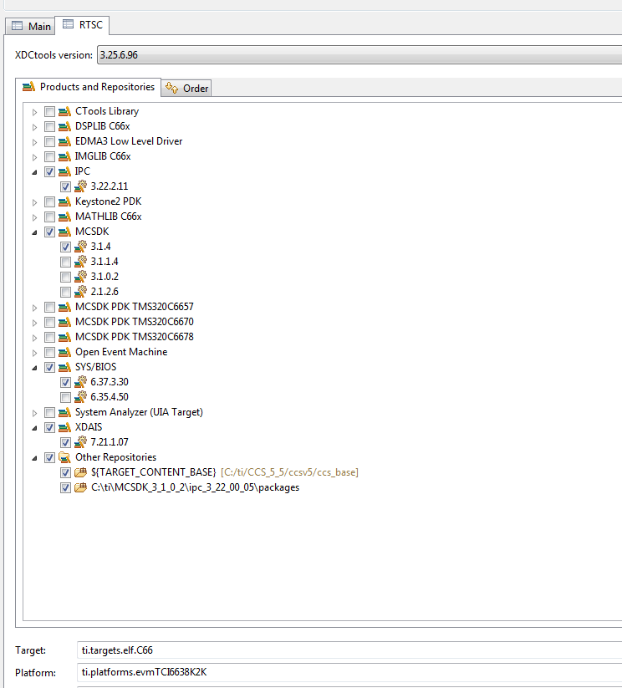

1. Use the pull down menu to choose the XDC version to use. Different versions of xdc exist in the CCS install and in the MCSDK install. Choose the latest XDC and make a comment of the XDC version.
2. Add the path to **ti/csl/csl.h**  
     
   Find the path in your release. In my release, the path is:  
     
   **C:\ti\MCSDK_X_Y_Z\pdk_keystone2_X_Y_Z\packages**

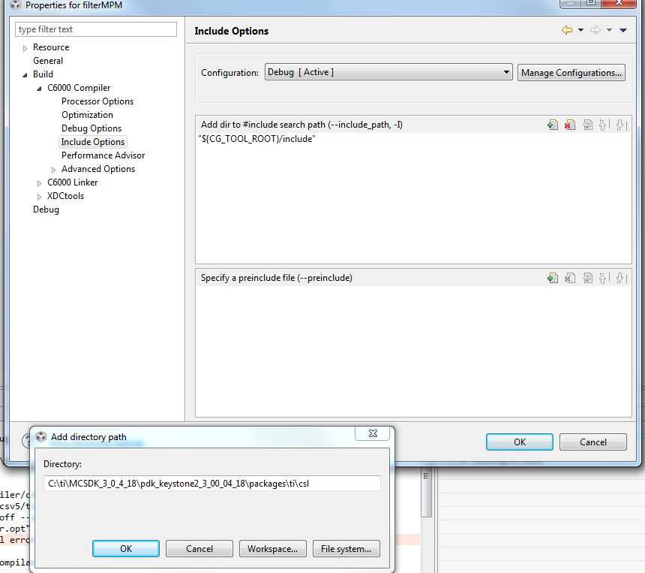

1. Adding the device name to include device specific include file instead of including the file explicitly. Properties->Advanced Options->predefine Symbol and enter the device name, DEVICE_K2H or DEVICE_K2K (both share the same definitions)

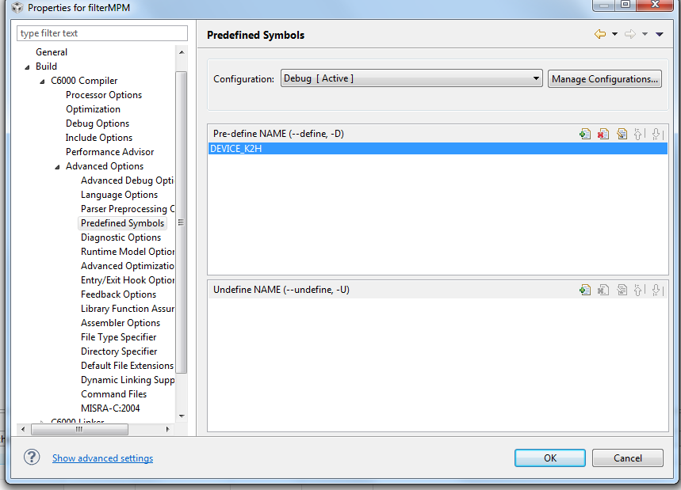

1. Adding the csl library and the path to the library. To do so click on the link tab, file search path and enter the csl library ti.csl.ae66 at the top window. Add the path to the library at the lower window. In my setting the path to the csl library is C:\ti\MCSDK_3_1_4\pdk_keystone2_3_01_01_04\packages\ti\csl\lib\k2k\c66 The following screen shot shows the adding of the csl library and the path:

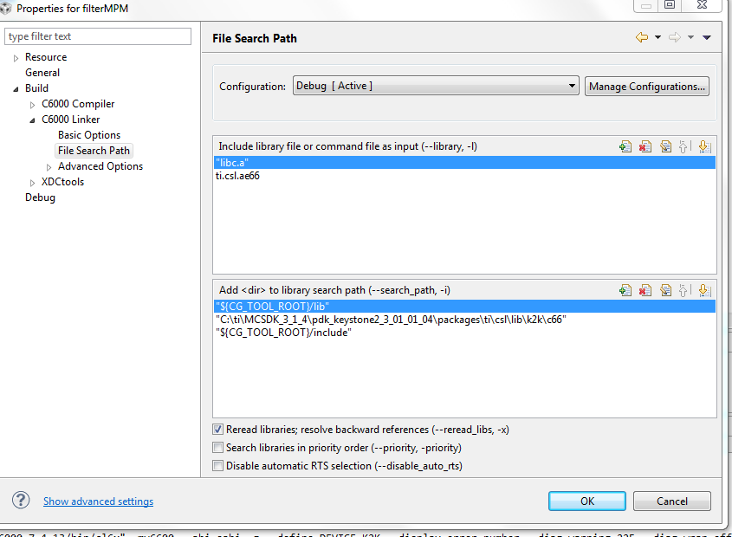

1. If you have not set the platform before, click on the General tab, RTSC, click on the platform tab at the bottom of the dialogue box and select **ti.platform.evmTCI6638K2K**platform
2. Select OK to close the property dialogue window.

NOTE: RTSC projects require the user to select three types of information.

* The device family in the CCS create page determines what core is used and thus what version of the compiler should be used (different cores have different intrinsic functions).
* The platform that is defined here determines the memory configuration of the core.
* To build the correct RTSC drivers, the device name should be defined. This is done by adding a predefined symbol with the device name. More about it later.

1. Right click on the project name and select *rebuild*. If the build goes correctly, you will see the following in the console window. NOTE: Look at the debug directory to ensure that the file **mpm_example_sum.out** is there. Ignore any warnings.
2. Look at the map file (located in the Debug sub-directory) and notice that DDR address 0x8000 0000 is used in the project.

******************************************************************************

TMS320C6x Linker PC v7.4.8

******************************************************************************

>> Linked Thu Oct 02 13:46:19 2014

OUTPUT FILE NAME: <filterMPM.out>

ENTRY POINT SYMBOL: "_c_int00" address: 8011ca80

MEMORY CONFIGURATION

name origin length used unused attr fill

---------------------- -------- --------- -------- -------- ---- -------

L2SRAM 00800000 00100000 0002fcb4 000d034c RW X

L1PSRAM 00e00000 00008000 00000000 00008000 RW X

L1DSRAM 00f00000 00008000 00000000 00008000 RW

MSMCSRAM 0c000000 00600000 00028000 005d8000 RW X

**DDR3 80000000 20000000 001211e0 1fedee20 RW X**

### Task 2: Using MPM to Load, Run and Observe Results

In this part, we assume that the EVM is boot in net mode. That is, the file system is on the server and mounted to the EVM as done in Lab 3.

1. Find the location where the .out file resides. To do so, find the outfile in the debug directory of the project, select the outfile, and right click properties. Look at the location at the top of the open dialogue.



1. From the VNC, navigate to your directory **/opt/filesys/studentN**
2. Change the permission of the bin subdirectory:  
   **sudo chmod 777 –R bin**
3. FTP the out file onto the server at **/opt/filesys/studentN/bin**  
   Where N is the student number
4. Change the permission of the out file

**cd bin**

**sudo chmod 777 mpm_example_sum.out**

1. Reboot the EVM using NFS.
2. From the terminal login as **root**
3. **cd /bin**
4. Use MPM to reset, load, and run core 0 with **mpm_example_sum.out** by using the following MPM commands:  
     
   **mpmcl reset dsp0  
   mpmcl load dsp0 mpm_example_sum.out**

You get an error message as follows:

**root@k2hk-evm:/bin# mpmcl reset dsp0**

**[ 790.263525] remoteproc0: stopped remote processor 2620040.dsp0**

**reset succeeded**

**root@k2hk-evm:/bin# mpmcl load dsp0 mpm_example_sum.out**

**load failed (error: -104)**

### Task 3: Using direct addressing and Run Again

1. The source code main.c defines a pointer to the output vector outputData[]. A pragma DATA_SECTOR tells the compiler to allocate the vector in the section .DDR3. The linker command file link_file.cmd tells the linker to put this vector in the DDR3 memory.
2. If the symbol VECTRO_DEFINE is not defined, then the pointer p2 will get its value from direct assignment, and this value will be in the DSP reserved area (0xE000 0000) See the following:

**#define** VECTOR_DEFINE

**#define** NUMBER_OF_ELEMENTS 1024

**int** *p_output ;

**#ifdef** VECTOR_DEFINE

**#pragma** DATA_SECTION (outputData, ".DDR3")

**#pragma** DATA_ALIGN (outputData,8)

**int** outputData[NUMBER_OF_ELEMENTS];

**int** *p2 = (**int** *) &outputData[0] ;

**#else**

**int** *p2 = (**int** *) 0xe0000000 ;

**#endif**

1. In the main.c file, comment out the definition of VECTOR_DEFINE

**// #define** VECTOR_DEFINE

1. Save and rebuild the project. Look at the map file. This time it looks like the DDR memory is not used;

******************************************************************************

TMS320C6x Linker PC v7.4.13

******************************************************************************

>> Linked Mon Feb 23 10:27:42 2015

OUTPUT FILE NAME: <mpm_example_sum.out>

ENTRY POINT SYMBOL: "ti_sysbios_family_c64p_Hwi0" address: 00819800

MEMORY CONFIGURATION

name origin length used unused attr fill

---------------------- -------- --------- -------- -------- ---- --------

L2SRAM 00800000 00100000 0001a00c 000e5ff4 RW X

L1PSRAM 00e00000 00080000 00000000 00080000 RW X

L1DSRAM 00f00000 00080000 00000000 00080000 RW

MSMCSRAM 0c000000 00600000 00000000 00600000 RW X

DDR3 80000000 20000000 00000000 20000000 RW X

DDR3_forDSP e0000000 20000000 00000000 20000000 RW X

1. Repeat Task 2 of the Lab (ftp the out file to **/opt/filesys/studentN/bin**) and repeat the process. This time you will be able to load and run the code. The following is a screen shot after running the new program.

root@k2hk-evm:/bin#

root@k2hk-evm:/bin# mpmcl reset dsp0

reset succeeded

root@k2hk-evm:/bin# mpmcl load dsp0 mpm_example_sum.out

load succeeded

root@k2hk-evm:/bin# mpmcl run dsp0

[ 7415.136643] remoteproc0: powering up 2620040.dsp0

run succeeded

1. Look at the trace 0 file the end of the run

root@k2hk-evm:/bin# cat /sys/kernel/debug/remoteproc/remoteproc0/trace0

4 values start at 964 2912 14543 2918 14573

4 values start at 968 2924 14603 2930 14633

4 values start at 972 2936 14663 2942 14693

4 values start at 976 2948 14723 2954 14753

4 values start at 980 2960 14783 2966 14813

4 values start at 984 2972 14843 2978 14873

4 values start at 988 2984 14903 2990 14933

4 values start at 992 2996 14963 3002 14993

4 values start at 996 3008 15023 3014 15053

4 values start at 1000 3020 15083 3026 15113

4 values start at 1004 3032 15143 3038 15173

4 values start at 1008 3044 15203 3050 15233

4 values start at 1012 3056 15263 3062 15293

4 values start at 1016 3068 15323 3074 15353

4 values start at 1020 3080 15383 3086 15413

Setting 'global_variable' to 1

# Lab 8: ARM Optimization Using SMP Linux

## Projects and Source Code

Unless instructed by the instructor otherwise, all projects and source code are available on the server. Directory **/global/Projects** has two sub-directories, ARM and DSP. The source for this ARM sub-directory is in the ARM subdirectory in a subdirectory called SMP.

## Purpose

The purpose of this lab is to demonstrate how the SMP LINUX distributes threads between multiple cores and as a result, speed, up the processing of time sensitive application, running on the four ARM A15 cores of the KeyStone II device.

The default application is a typical signal processing fir filter algorithm. Fir filters can be easily partitioned between multiple threads. The program was structured such that it is very easy to replace the fir filter with any generic easy-to-partition application.

### Task 1: Copy the Source Files

It is assumed that the file system is mounted to the EVM (NFS boot, setenv boot net) and that the file system is in location **/opt/filesys/studentN** where N is the student number.

1. From the VNC window log-in as your student name (user name studentN, password WsN where N is the student number) and run the initialization script file.  
     
   Source: **/global/scripts/studentStartOutsideTI.sh**
2. In the studentN file system location make a new directory (if it does not exist already) and name it applications and then make a subdirectory smp_test

**cd /opt/filesys/studentN**

**sudo mkdir applications**

**cd applications**

**sudo mkdir smp_test**

**cd smp_test**

NOTE: If the file system is located in a different directory, change the instructions accordingly. Next, copy the four source files to the new directory:

**sudo cp /global/Projects/** **smp_threads /smp_test.c .**

**sudo cp /global/Projects/** **smp_threads /multithreads.h .**

**sudo cp global /Projects/** **smp_threads /application.c .**

**sudo cp / global/Projects/** **smp_threads /application.h .**

1. Last copy the three Makefiles to the new directory

**sudo cp /global/Projects/smp_threads /Makefile_no_optimization.mak .**

**sudo cp /global/Projects/** **smp_threads /Makefile_O2_optimization.mak .**

**sudo cp /global/Projects/smp_threads /Makefile_full_optimization.mak .**

**Questions**

Assume you want or need to change the algorithm that runs on the A15.

1. Does the file smp_test.c need to be changed?
2. Does the include file multithreads.h needs to be changed?
3. Does the file application.c need to be changed or replaced?
4. Does the file application.h need to be changed or replaced?
5. Which instruction spans threads?
6. Optional: What does each of the parameters of the clone () function represent?

### Task 2: Compile, Build, & Run the Project on a Single Core

##### Cross Compiler Instructions (you can use the native tools)

From the VNC terminal, you need to build the project. The path to the cross compiler should be defined. To verify this, do the following:

**printenv |grep arm**

**printenv |grep gcc**

The output on the terminal will appear as follows:

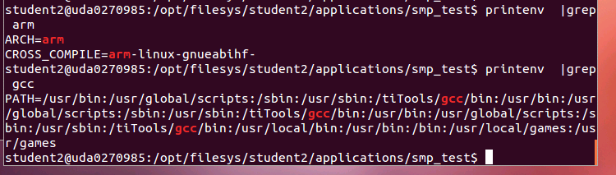

Make sure that the path to **arm-linux-gnueabihf** is defined and the **arm-linux-gnueabihf** is defined as the CROSS_COMPILER

First build the project with full debug and no optimization:

**make –f makefile_No_Optimization.mak**

Note that the optimization flag (dash capital O) is set to zero, and there is –o (small o) to **smp_test_no_optimization.out** Thus, the built project will have the name **smp_test_no_optimization.out**.

Before running the code, you need to verify that the EVM is connected to the local network via Ethernet, that you have a terminal window (either Putty or Tera Term or other) into the EVM as explained in previous labs, and that NSF boot from TFTP is working.

1. Power on the EVM
2. Wait for the login screen.
3. Login as root:

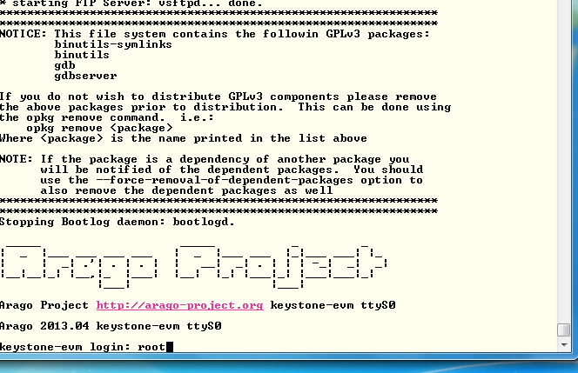

1. Change the location of the terminal to the smp_test directory:

**cd /applications/smp_test**

**ls**

The four source files, the three Make files, and the a.out file should be in the directory.

1. To run the code with a single thread, first ensure that the file a.out has executable permission:

**chmod +x smp_test_no_optimization.out**

1. Run the code:

**./smp_test_no_optimization.out 1**

After a few seconds (wait until all the printing is done), the results should appear as follows:

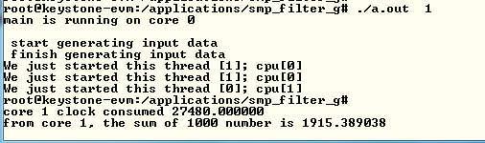

1. Record the clock consumed value in the table (next page).
2. Back in the VNC window re-build the executable with O2 optimization:

**make –f makefile_O2_Optimization.mak**

1. Run **smp_test_o2.out** The results should look like the following:

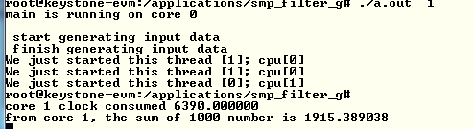

1. Back in the VNC window, re-build the executable with full optimization:

**make –f makefile_full_Optimization.mak**

1. And run smp_test_full.out

**Questions**

1. What is the speed-up percentage of performance improvements when the optimization O2 is on?
2. What is the speed-up percentage of performance improvements when the full optimization is on?
   * Compare to non-optimization
   * Compare to –O2

### Task 3: Run the Code on Multiple Cores

From this point on you only run the full optimized version of the a.out executable.

In this task you run the program on multiple cores. While the total processing time on all the cores remains almost the same, the elapsed time (the time that the slowest core consumes) will be reduced almost linearly by the number of cores that are involved.

The SMP operating system will distribute threads between cores. The number of thread in this program is limited to 32, but the number of cores is 4. So if the number of threads is bigger than 4, multiple threads will be assigned to each core.

Run the following cases and compete the table below:

**./ smp_test_full.out 1**

**./ smp_test_full.out 2**

**./ smp_test_full.out 4**

**./ smp_test_full.out 8**

**./ smp_test_full.out 16**

**./smp_test_full.out 32**

|  |  |  |  |  |  |  |
| --- | --- | --- | --- | --- | --- | --- |
| **Number of threads** | **Core 0 total time consumed** | **Core 1 total time consumed** | **Core 2 total time consumed** | **Core 3 total time consumed** | **Slowest core time consumed** | **Total time consumed by the 4 cores** |
|  |  |  |  |  |  |  |
|  |  |  |  |  |  |  |
|  |  |  |  |  |  |  |
|  |  |  |  |  |  |  |
|  |  |  |  |  |  |  |
|  |  |  |  |  |  |  |

**Questions**

1. The shared ARM L2 cache is 4MB. Do all the vectors fit into the cache?
2. The private L1 cache for each ARM A15 core is 32KB. What is the maximum input vector that will not cause L1 cache to be trashed?
3. What is the speed-up percentage when four cores are used compared to a single core?
4. How does the cache size effect the total time when multiple threads are used?

# Lab 9: Inter-Processor Communication (IPC)

## Projects and Source Code

The original files for this Lab are part of the MCSDK release. The student will copy MCSDK release into his private directory (**studentN/MCSDK_X_XX**) before changing any file.

## Purpose

The purpose of this lab is to demonstrate messages transfer between the ARM and the DSP cores. The source code may be a starting point for customer who needs sending messages and data between cores.

### Task 1: Run the Demo from a Web Server

#### Step 1: Boot and Obtain IP Address

The file system that is loaded into the EVM should be tisdk based file system. Boot the EVM using NFS (mount) boot and wait until the display on the EVM gives the IP address of the board. Note that the display flips between several messages. IP address is one of the messages.

#### Step 2: Start Terminal Session

Open a terminal into the EVM and log in as root

#### Step 3: Access Matrix Application Loader

From a computer that is on the same sub-net as the EVM, or from VNC into a computer that is on the same subnet as the EVM, start Firefox (or any other browser) and put the IP address of the EVM as shown in the following screen shot. The EVM in the screen shot has IP address of **192.168.0.24**.

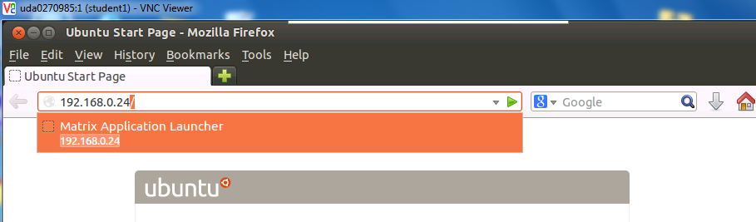

If the Firefox is connected via VNC, Ubuntu may ask you if you have a display device. Answer OK. The EVM respondx with a set of out-of-the-box applications as seen in the next screen:

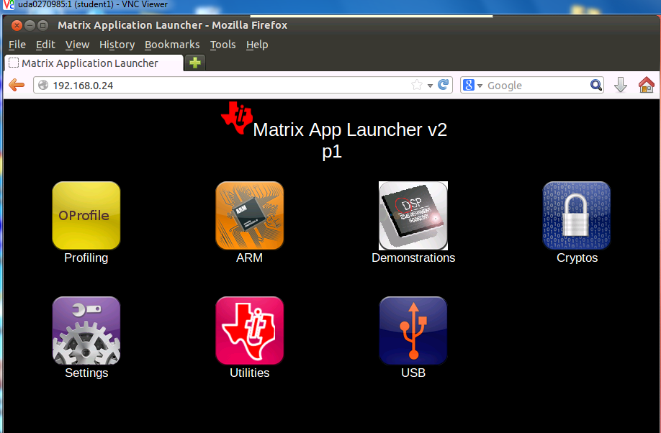

It is highly recommended to go through each one of the applications. However, in this lab we only use the IPC demo. Click on the Demonstrations tab and then the IPC Demo. The next screen shot will be displayed:

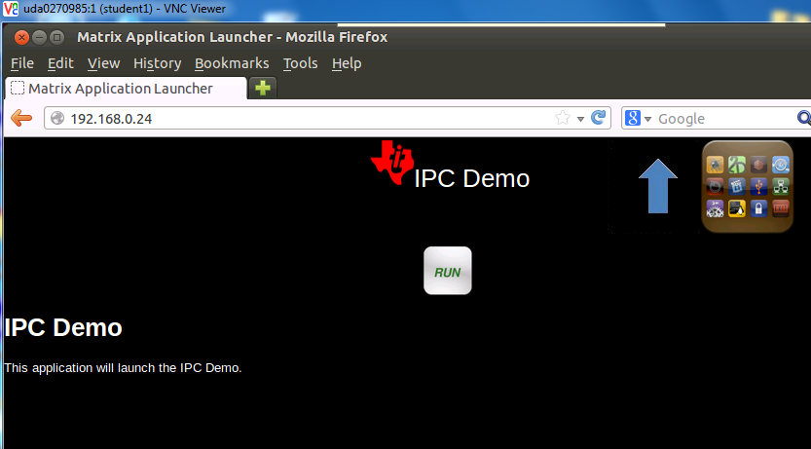

Click on RUN and follow the progress on the browser and on the terminal that is connected to the EVM.

The browser display:

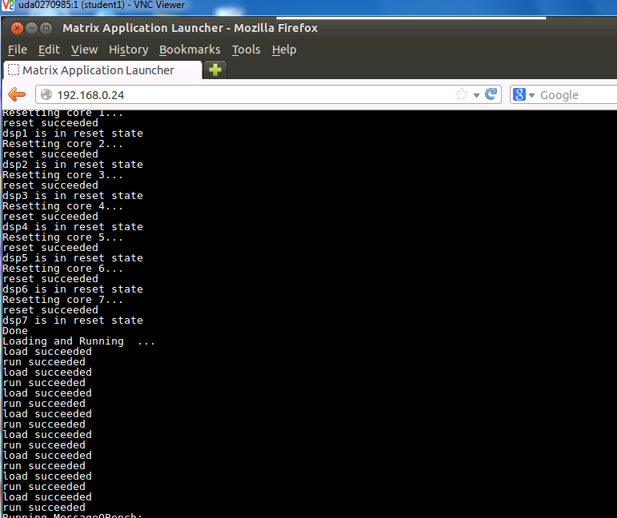

You may have to use the arrow to see the complete execution of the demo. The last lines are the following:

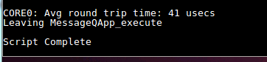

The terminal that is connected to the EVM displays something like:

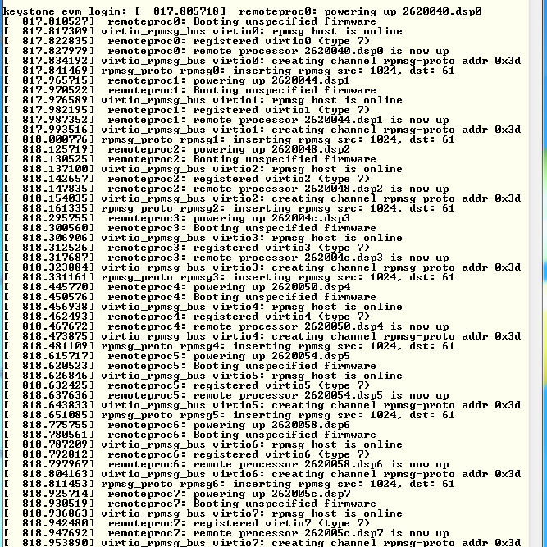

Follow the messages on the terminal and see what software modules are used (remoteproc, virtio, rpmsg).

### Task 2: Run the Demo from the Terminal

#### Purpose

The purpose of this task is to familiar the user with the directory structure and the main files of the demo

#### Step 1: Observe the File demo_ipc.sh

In the directory **/usr/share/matrix-gui-2.0/apps/demo_ipc** there are three files:

1. **demo_ipc.desktop**
2. **demo_ipc.sh**
3. **desc_demo_ipc.html**

Look at the file **demo_ipc.sh** using vi, more, less, cat or any other utility.

The following screen shot was taken using cat:

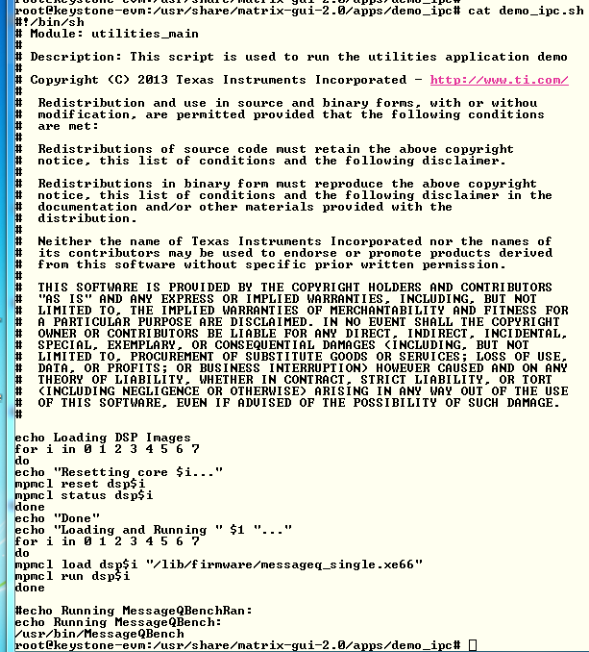

Notice that the DSP code is loaded from directory **/lib/firmware** and the name of the execution is **message_single.xe66**. The Linux code is loaded from directory **/usr/bin** and the executable name is **MessageQBench**. In the next task, you will build these two executable files in your local directory and move them to your private file system.

#### Step 2: Run the File demo_ipc.sh

In the terminal, move to directory **/usr/share/matrix-gui-2.0/apps/demo_ipc** (**cd /usr/share/matrix-gui-2.0/apps/demo_ipc**) and run the **sh file ./demo_ipc.sh** as shown the following screen shots:



After the run, the terminal looks like the following:

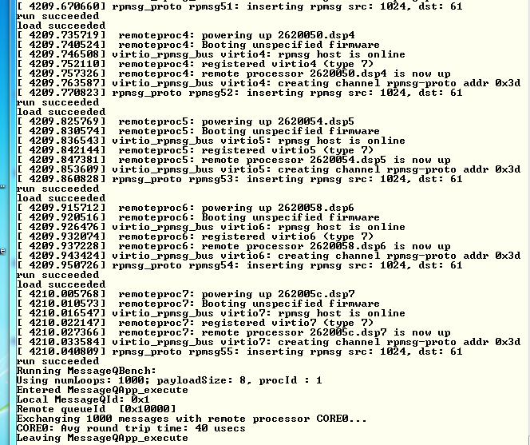

### Task 3: Rebuild the Executable

#### Purpose

In this task, the student will re-build the DSP and ARM executable to prepare for modifying the code for a new project.

#### Step 1: Get a Private Copy of IPC from the Release

Back to VNC window … In your home directory **/home/student**, create a new directory named IPC and move there:

**sudo mkdir IPC**

**cd IPC**

Copy the IPC directory from the latest release into the new created private directory. Currently, the latest release is release 3_18:

**sudo cp -R /tiTools/MCSDK_3_4_18/ipc_3_00_04_29 / .**

**cd ipc_3_00_04_29**

**ls**

The directory should look like the following:

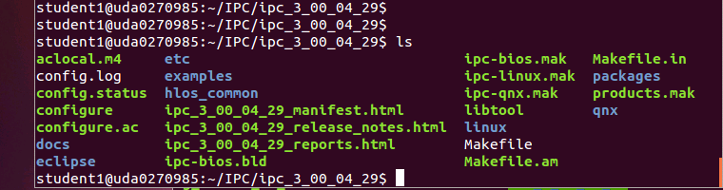

#### Step 2: Build the ARM Executable

Detailed instructions how to install and build the Linux version of IPC are in the file **IPC_Install_Guide_Linux.pdf** that is part of the release in directory **\MCSDK_3_4_18\ipc_3_00_04_29\docs**. The install part of the IPC is already in the release. So we will start with the build procedure.

First, set the environment variables in the file **products.mak** in the directory **ipc_3_00_04_29** (or any later version of IPC) as follows:

**DEPOT (Optional, depends how you define the other variables)**

**TOOLCHAIN_LONGNAME**

**TOOLCHAIN_INSTALL_DIR**

**PLATFORM**

**KERNEL_INSTALL_DIR**

**XDC_INSTALL_DIR**

**BIOS_INSTALL_DIR**

**ti.targets**

The IPC install guide explains what needs to be set in the variables mentioned above. The following is an example of the definition. You may have to modify the variables based on structure of your system.

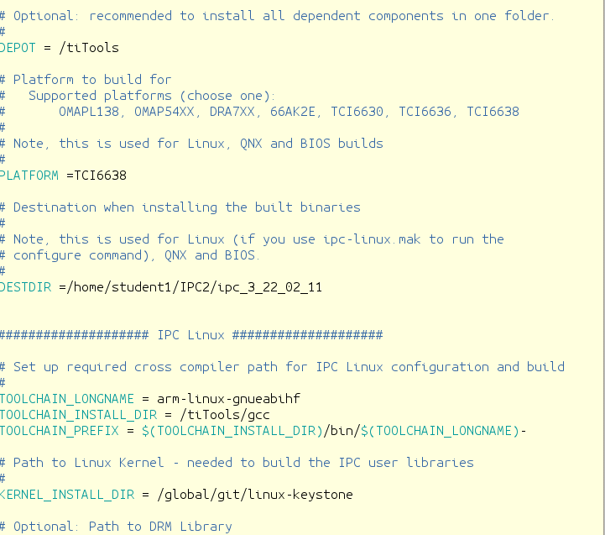

The platform is TCI6638 (Hawking).

The **TOOLCHAIN_INSTALL_DIR** is the location where the Linaro tools were installed on the server.

The **KERNEL_INSTALL_DIR** is where the kernel sources were installed using the git repository **/global/git/linux-keystone**.

The **TOOLCHAIN_PREFIX** is the final location where the linaro tools are the gcc and all other tools are located. It must have the – at the end

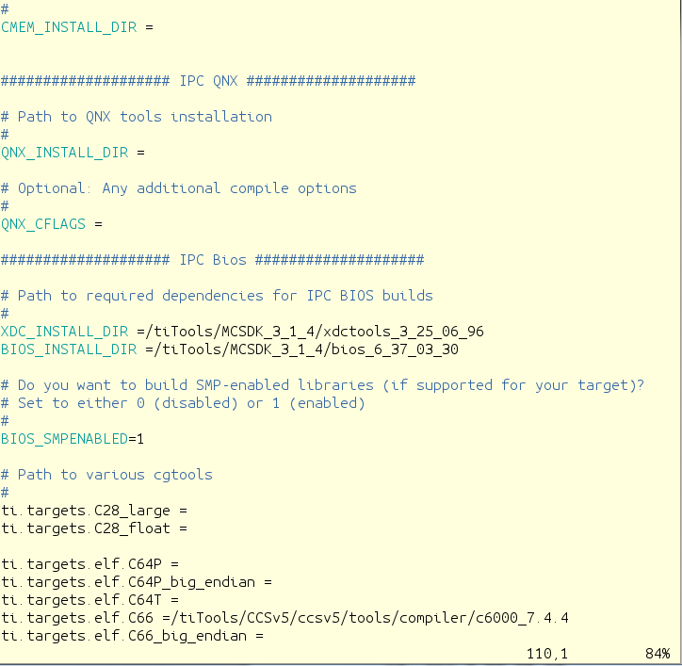

**XDC_INSTALL_DIR** is part of the MCSDK release and the location points to where the XDC part of the MCSDK was installed. The same is true for the **BIOS_INSTALL_DIR**. The **ti.targets.elf.c66** is the location of the code generating tools for this platform. The tools location is part of the CCS release. The CCS was installed in **/tiTools/CCS5_v5** directory.

In order to manipulate files in the ipc directory you have to change the permission. Since this is a private copy on a local network, you can give full permission.

**cd ..**

**sudo chmod 777 –R ipc_3_00_04_29**

**cd ipc_3_00_04_29**

Next, run the make utility with the Linux makefile:

**make –f ipc-linux.mak config**

When building a second time, you have to clean the environment before:

**sudo make clean**

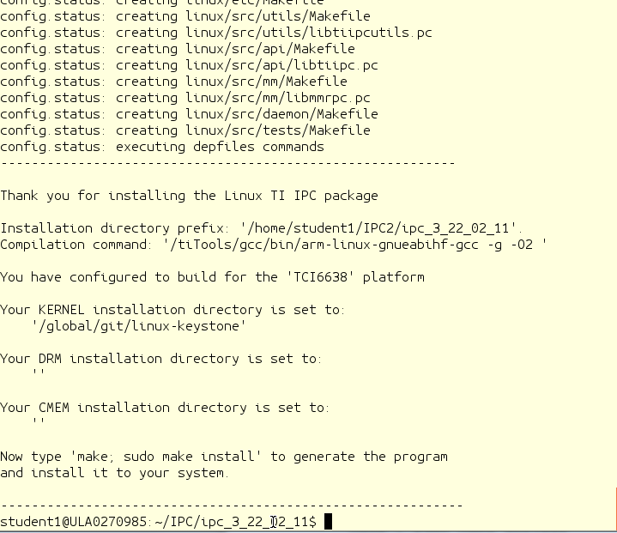

The screen prompts you to run the next make

**make ; sudo make install**

Follow the printing in the window. It may ask you for a password for the sudo part. The following screen shot shows the end of the build. In case of error, see the note after the screen shot. Note that the script reports an error at the end, (libtool: line 6556: arm-linux-gnueabihf-ranlib: command not found ). Ignore this error; the executable was built, though some of the libraries may not be rebuilt. In addition, the script might ask you for the sudo password during the execution.

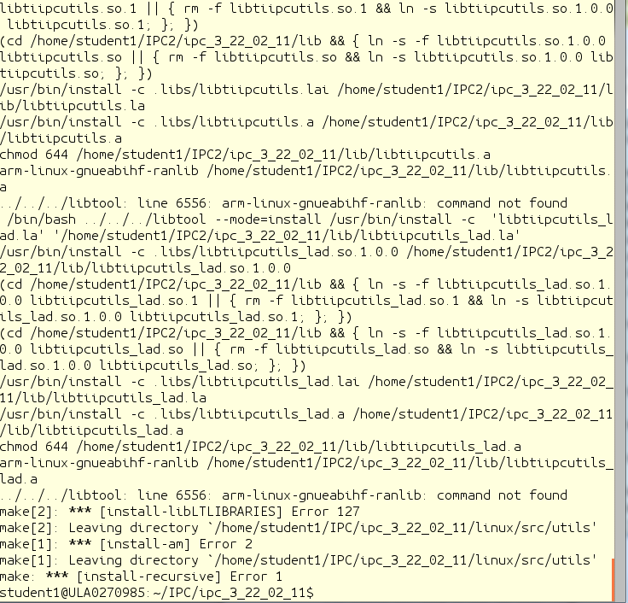

The build process builds several files. The file **MessageQBench** in directory **linux/src/tests/** is a temporary wrapper script file that shows how the build is done. The file **MessageQBench** (yes, the same name) in directory **linux/src/tests/.libs** is the executable. After the build, move this file to the file system location:

**sudo cp linux/src/tests/.libs/MessageQBench /opt/filesys/studentN/usr/bin/.**

Verify that the executable in the **/opt/filesys/studentN/usr/bin** directory is the one that you built by doing **ls –ltr MessageQBench** and verifying the data and time.

#### Step 3: Build the DSP Executable

Detailed instructions how to install and build the DSP-BIOS version of IPC are in the file **IPC_Install_Guide_BIOS.pdf**, which is part of the release in directory **\MCSDK_X_Y_Z\ipc_X_Y_Z\docs**. The install part of the IPC is already in the release, so we will start with the build procedure.

The environment variables in the file products.mak were already set in the previous step.

Return back to the ipc directory

Next step is to run the make utility with the linux makefile:

**cd ~/IPC/ipc_3_00_04_29 (or a newer version of IPC)**

**make –f ipc-bios.mak all**

The build will take several minutes. The following is a screen shot when the build is done:

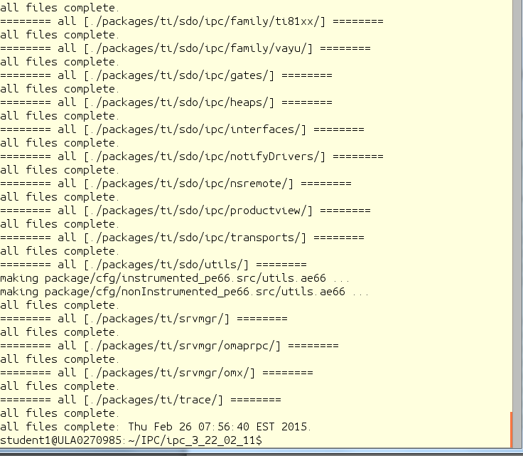

The executables are built in the directory **IPC/ipc_X_Y_Z/packages/ti/ipc/tests/bin/ti_platforms_evmTCI6638K2K_core0**. There are five ex executables as follows:

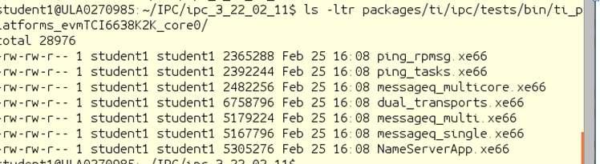

The file **messageQ_signal.xe66** should be copied to the file server at location **/opt/filesys/studentN/mcsdk_x_XX/lib/firmware**

**sudo cp packages/ti/ipc/tests/bin/ti_platforms_evmTCI6638K2K_core0/messageq_single.xe66 /opt/filesys/student1/lib/firmware/.**

Verify that the executable in the **/opt/filesys/studentN/lib/firmware** directory is the one that you built by doing **ls –ltr messageQ_single.xe66** and verify the data and time

From Tera Term, run the **demo_ipc.sh** again. Verify that it is working.

**/usr/share/matrix-gui-2.0/apps/demo_ipc/demp_ipc.sh**

### Task 4 (Optional): Modify Source Code & Rebuild Executable

#### Purpose

In this task the student will change the ARM code and the DSP code, build and run the executable

You are welcome to do any change you want. The following instructions and screen shots will show how to add an index to the message from the ARM to the DSP, and the DSP will read the index, add 1000 to it and send it back to the ARM.

#### Step 1: Modify the ARM Code

The demo source file is MessageQBench.c in directory /IPC/ipc_3_00_04_29/linux/src/tests. Following the source file, it looks like the ARM allocates a message, sends it to the DSP, and then gets the message back and make sure that the data was not corrupted during the transfer. The changes that are suggested for the ARM side are the following:

1. Modify a printf statement to show that the code has been modified
2. Adding an additional value (or values) to the message, load the additional value with a known data, and print the additional information from the DSP side.Here are the suggested changes:
3. Enable printing from the DSP side. This is done by changing the second parameter in the first control message to TRUE. Note that by enabling printing, the execution time is increased.

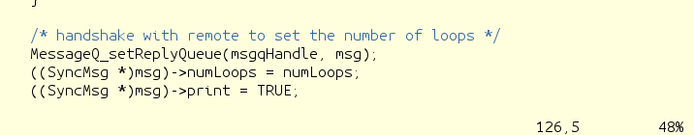

1. Load the next value in the message to ten times the index number:

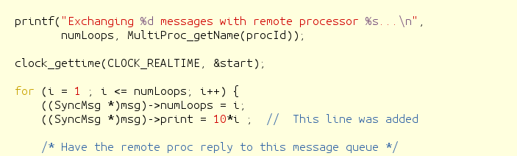

1. In the DSP the second value will be read, multiplied by 10 and sent back to the ARM. Thus in the ARM print the receive value and compare it to 100*index (10 times in the ARM and 10 times in the DSP

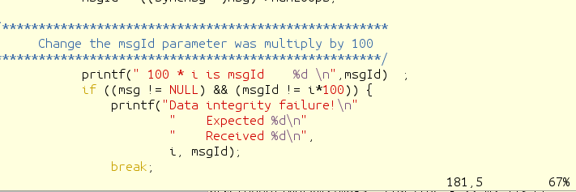

#### Step 2: Build the ARM Code

Repeat the steps from the previous task and re-build the ARM executable MessageQBench

#### Step 3: Modify the DSP Code

The DSP source function messageq_single.c is in directory IPC/ipc_3_00_04_29/packages/ti/ipc/tests .

1. Add a new variables newVar1 and newVar2 to the tsk1Fxn

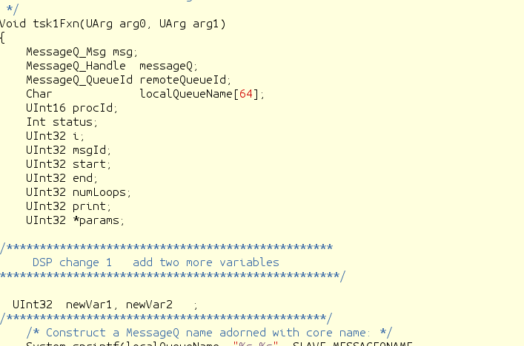

1. Load the new values value from the ARM message and print it. (The value is 10*I, and the System_printf prints on the DSP trace buffer that is accessed by the Linux)

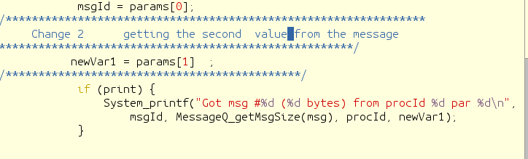

1. DSP core multiplies the new values by 10 (again, so now it is 100*I), adds it to the message and sends the message back to ARM

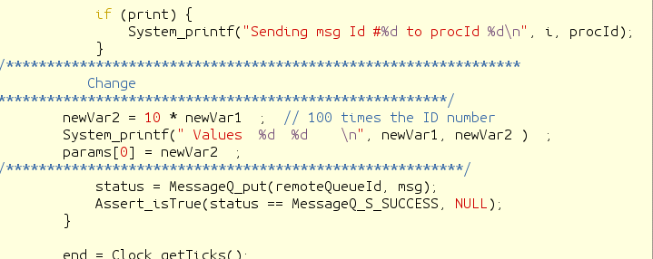

#### Step 4: Build the DSP Code

Follow the instructions from the previous task.

#### Step 5: Run the File demo_ipc.sh

Follow the instructions of Task 2.

1. Observe the printing on the terminal to see the changes that you did in the printf of the ARM code
2. Look at the ARM trace buffer of DSP core 0 and see all the printing that arrived from the DSP:

**Cat sys/kernel/debug/remoteproc/remoteproc0/trace0**

Here are some screen shots from the terminal during running the script:

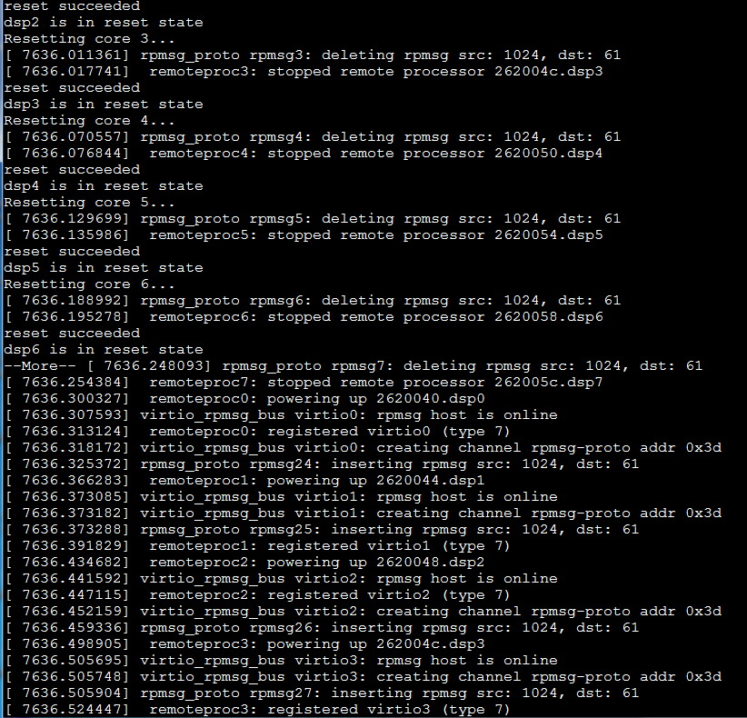

The ARM prints messages back from the DSP:

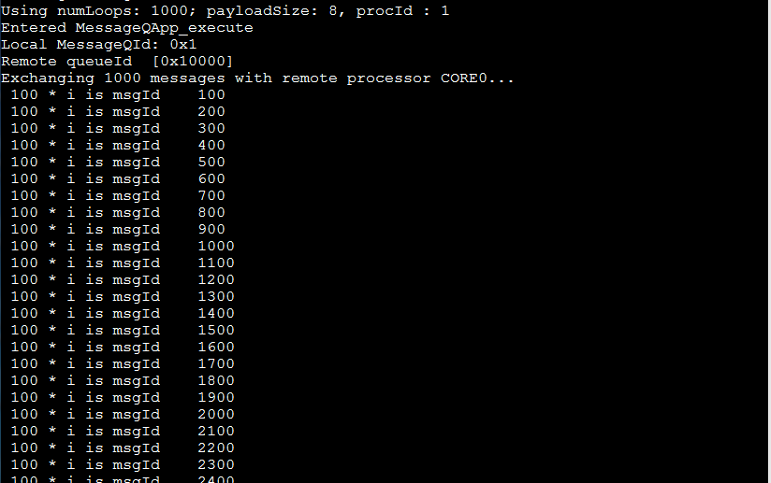

Looking at the trace buffer for the DSP System_printf, and remember that this is a circular buffer:

